Syrian Arab republic
ministry of education
the national center for the distinguished
The Classical Guitar
حلقة بحث مقدمة بمادة اللغة الإنكليزية
تقديم الطالبة : رند تميم سلمان
بإشراف المدرسة :صبا منصور
للعام الدراسي : 2014 – 2015
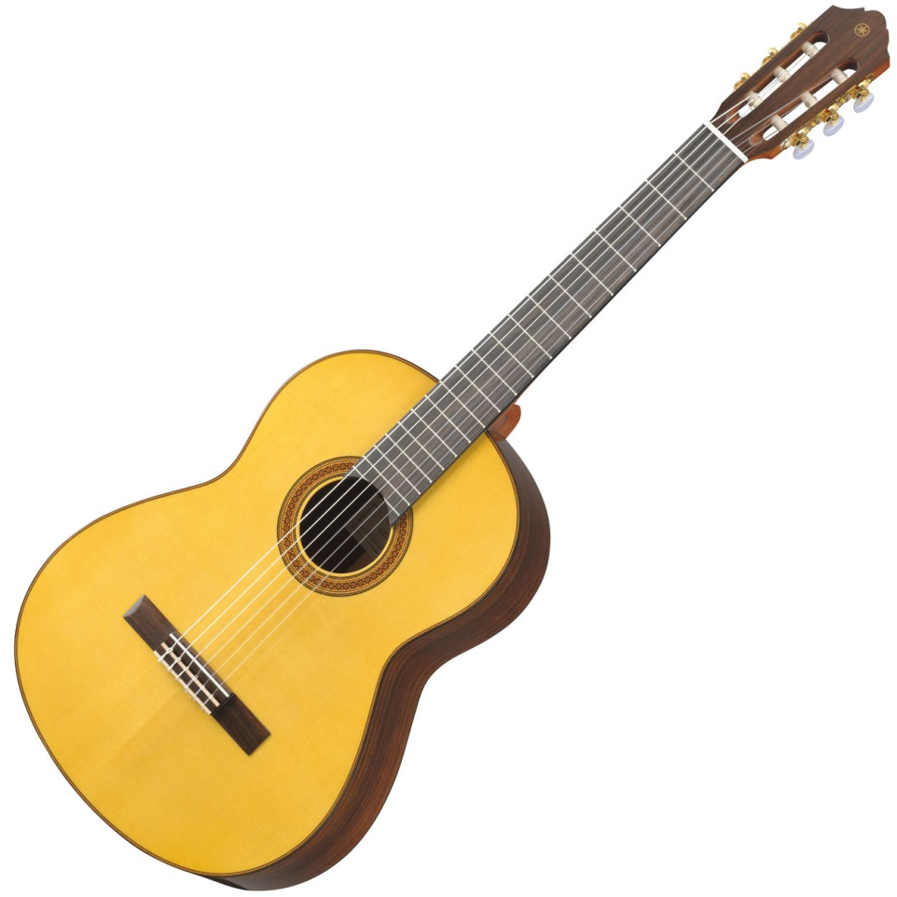

The index :

Introduction …………………………………………….…. 2

Chapter one :
The developments of the guitar .………….. 5
First guitar ………………………………………… 6
Chapter two :
Guitar sections ……………………………………….. 9
Guitar strings …………………………………….…..10
Some guitarists ……………………………………..11

Conclusion ……………………...……………………..12
References ……………………………………………..13

The index of the pictures :

The page | The name of the picture | The number of the picture
7 | Five-course Guitarra Battente | 1
10 | Guitar sections | 2

The introduction :
The word guitar conjures in the contemporary American mind images of rock stars and ten million dollar annual incomes, incredible solos and blaring amplifiers, shaggy-haired bassists and dynamic lead guitarists wailing until they lose their voices and numb their fingers. Evidence of this is to be found on the shelves in any Borders or Virgin Records in the country, where Metallica and Nirvana sit comfortably on the countless rows of the compact discs of hundreds of other similar artists; it resides in the basements of most prepubescent boys, where the standard wreck of a hand-me-down guitar squeaks in a horribly out-of-tune version of something approximating “Stairway to Heaven.” America is indeed enthralled by the guitar. Whether Muddy Waters dons a slide or NoFX attacks modern society in musical form, America is listening intently.
However, at one time this instrument was considered secondary and even unfit for playing in public venues, and in fact cannot even be traced back before the 15th century with any real certainty or before the 13th at all. At certain times in history, one would even be hard pressed to identify one of the predecessors as a guitar at all, as size, shape,
number and type of strings, body structure, and sound quality have varied tremendously over time. Of these, many older models have fallen apart or become unplayable; only brief historical allusions and artists’ renderings have survived, and those in scarce quantities. However, experts have come to accept a certain general historical progression
of the development of the modern guitar.
So , what is the history of the classical guitar ?
What are the diffirence between the old and the modern sections ?
And what are the most beautiful kinds of music to play on it.
The developments of the guitar by the years :
Guitar forefather can be investigate to three thousand years BC, before the Egyptian Nefer, the ancient Babylon, and the ancient Persia, a variety of ancient plucked string instrument. Archaeologists found the oldest stringed instruments, bowl harps and tanburs.
First guitar :
The raw materials are quite simple. Tortoise shells and calabashes are used to make resonators. A bent stick is used for a neck and one or more gut or silk are strings. Around 2500 – 2000 BC more advanced harps, such as the opulently carved 11-stringed instrument with gold decoration was found in Queen Shub-Ad‟s tomb, started to appear. In early time, the Moors brought the oud to Spain. The Europeans developed the oud by adding frets and called the advanced oud as a “lute”. The other branch of development is in the Arabian counties. They changed its proportions of different components and remained fretless necks.
Guitars were defined as having a long, fretted neck, flat wooden soundboard, ribs, and a flat back, most often with incurved sides. The name “guitar” comes from the ancient Sanskrit word
for “string” – “tar” . So many stringed folk instruments that existed have names that end in “tar”, with a prefix indicating the number of strings:
Two = Sanskrit “dvi” – modern Persian “do” – dotar, two-string
Instrument found in Turkestan.
Three = Sanskrit “tri” – modern Persian “se” – setar, 3-string
instrument, found in Persia (Iran)
Four = Sanskrit “chatur” – modern Persian “char” – chartar, 4-string instrument. Persia
Five = Sanskrit “pancha” – modern Persian “panj” – panchatar, 5 strings, Afghanistan
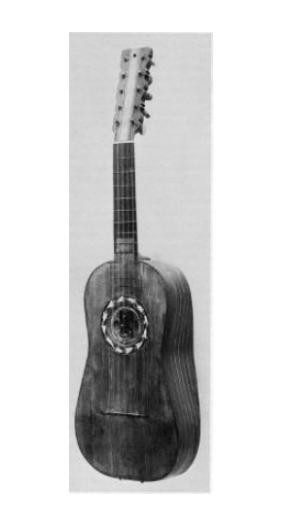
figure 1

By the beginning of the Renaissance, the four-course guitar had
Become dominant, at least in most of Europe. The five-course
Guitarra battente (below) first appeared in Italy in around the 16th century.
In around 1900, Torres started making his breakthrough fan-braced guitars. After this new type had moved to the USA, steel strings first became widely available, because of X-braced tops. At the end of the 19th century Orville Gibson was building archtop guitars with oval sound holes. In the early 1920‟s, the designer Lloyd Loar joined Gibson, and refined the archtop “jazz” guitar (f-holes, floating bridge and cello-type tailpiece).
Later on, between 1920 and 1940, electric guitars, amplifications and solid-body guitars sequence appear. But actually , Madrid is the mother of the guitar .

The name classical guitar does not mean that only classical repertoire is performed on it, although classical music is a part of the instrument's core repertoire (due to the guitar's long history); instead all kinds of music (folk, jazz, flamenco, etc.) are performed on it. The term modern classical guitar is sometimes used to distinguish the classical guitar from older forms of guitar, which are in their broadest sense also called classical, or more descriptively : early guitars. Examples of early guitars include the 6‐string early romantic guitar (ca. 1790 ‐ 1880), and the earlier baroque guitars with 5 courses.
Today's modern classical guitar is regarded as having been established from the late designs of the 19th century Spanish luthier Antonio Torres Jurado. Hence the modern classical guitar is sometimes called the "Spanish guitar".

Modern Guitar sections :
1- the head : it includes the tuning peg.
2- the neck : it is between the head and the body . is the long wooden piece of wood, flat on one side (this is called the fretboard) and curved on the other. The fretboard is inlaid with metalfrets that demarcate the different notes.
3- the body :
This is made up of lingo - cellulose plates (top plate, back plate, ribs) which vibrate, radiate and amplify the sounds .
The plates must have a thin thickness in order to vibrate under the exciting forces of strings. At the same time, these structures must resist to the cyclic stresses. Both requirements are fulfilled with the help of the stiffening braces glued on the top plates.
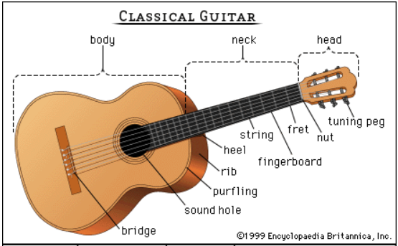
figure 2
The junction between the neck and the body is usually located at the 12th fret on the fingerboard, which is wider than the others. Nylon strings make the classical guitar sound simple and honest. It is mainly used for playing classical music. There are strict requirement from the playing position to the fingers and intensive skill. The classical guitar is the highest form of guitar art.

Guitar strings :
The strings run between the headstock of the guitar, where they are affixed totuning pegs that can be rotated to tighten and slacken them, and the bridge, where they're fixed to the guitar's body. And the strings are ( from the down to the top ) :
1- the E string .
2- the B string .
3- the G string .
4- the D string .
5- the A string .
6- the E string .
Its strings — today typically the treble strings (g‐b‐e') are nylon with the remaining 3 bass strings (E‐A‐d) being made of nylon fiber wound with metal thread. Though guitar strings are typically made of nylon today, animal gut strings (from the old tradition) are still available. The strings need to be replaced with new ones from time to time.
some guitarists :
- juan Moreno .
- Galina Vale.
- Alonso Mudarra.
- Lorenzo Alonso

CONCLUSION :
The guitar is an amazing musical instrument . it was well known to
Greece , Egyptians and Spanish, but it was first appeared in Italy.
It has developed through history and his style has changed too.
It is amazing for the romantic and classical music
It has 6 strings made from nylon.
Its 3 main parts are the head , the neck and the body .
The most famous guitar is the Spanish guitar.

Suggestions :
1- improve the quality of the guitar to be used in every events .
2- make some guitars in specials ways to can be used in eastern music and western music .
I hope you like this small introduction about this popular instrument .
References:
1-http://www.guyguitars.com/eng/handbook/BriefHistory.html. 1/2/2015 22:00 .
2-http://www.ranker.com/list/most-famous-classical-guitarists/music-lover?page=2. 1/2/2015 21:30
3- McFadden / Jeffrey James / Fretboard Harmony for University Study: Method and Historical Context / 2010 / University of Toronto.

4- rodriguez / manuel / The Art and Craft of Making Classical Guitars / 2009 / hal Leonardo books / USA .

5- wade / graham / A Concise History of the Classic Guitar / Philadelphia 1989 / 2010 / liepins , Andrew

6- Pellegrin / Harry George / Classic Guitar Method: A Complete Method / 2012 / library of congress cataloging .
7- NEW OPTIMAL PROCESS OF MAKING A GUITAR /
Wenbo / Zheng / 2010 /

McFadden / Jeffrey James / Fretboard Harmony for University Study: Method and Historical Context / 2010 / University of Toronto. P (8) .
25/12/2014 17:03 http://www.princeton.edu/~achaney/tmve/wiki100k/docs/Classical_guitar.html
NEW OPTIMAL PROCESS OF MAKING A GUITAR / Wenbo / Zheng / 2010 / p(12).
http:www.kids.britannica.com/comptons/art-52762/classical-guitar?
http://www.ranker.com/list/most-famous-classical-guitarists/music-lover?page=2. 1/2/2015 21:30

