A Research in English by the name:

Greek Mythology
Presented by: Laith Salameh
Grade: 10
Year: 2014-2015
Supervised by: Ms. Siba Mansour

Abstract:
This following research aims to spread the knowledge about mythology especially the Greek mythology since it’s really famous now a days and to question it whether it was right or wrong?

Index
i. Introduction …….(3)

ii. 1) What were the mythologies of the ancient world? …….(4)

2) Why is Greek mythology famous? …….(7)

3) The origin of the Greek myths …….(8)

4) The five ages of man according to the Greek …….(10)

5) What are the types of Greek myths? …….(12)

iii. Conclusion …….(15)

Photo index …….(16)
INTRODUCTION
From even before the beginning of the Greek civilization, which began around the year 1100 BC, story-telling was a tool of record-keeping. The Greeks began a form of story-telling called "mythology". The Greek myths were often about the Greek gods, heroes, and mortals, and usually taught a moral lesson, or helped one remember and recognize the power of the gods. Greek mythology created reasons for the occurrence of natural disasters, the creation of the earth, and sickness and disease. In our present age, Greek mythology is commonly thought of as primarily a form of entertainment, like any other story, but during the time of the Greeks, mythology was considered sacred, meaningful, and true. Though Greek mythology is merely considered a form of entertainment these days, it has greatly shaped much of what we have achieved up to this point. Greek mythology has influenced countless areas including language, astronomy, astrology, business, medicine, psychology, products, athletics, and even the weather. Greek mythology is both beneficial to us in our everyday lives, and influential in many ways.
So the first thing that will be on your mind after reading this introduction would be: what’s a myth? A simple definition of a myth is: a story handed down through history, often through oral tradition, that explains or gives value to the unknown or is intended to provide explanations for things that people did not understand. Most often myths explain natural phenomenon. They are especially linked to religious beliefs and rituals. Rituals were believed to invoke a type of magic that would aid the growth of crops, insure success in war, help achieve prosperity or make choices and promote stability in the land.
What is mythology?
The study of myths or a body of myths, as that of a particular people or that relating to a particular person: such as “Greek mythology”

1) The mythologies of the ancient world:
1.1) The Egyptian mythology:
Ancient Egyptian religion focuses largely on nature, beginning with the worship of animals. Animals were believed to represent the gods, who were imagined by individual tribes in early Egypt. Gradually, these sacred gods began to take human form with more distinct characteristics, but most continued to be depicted with the head of an animal.
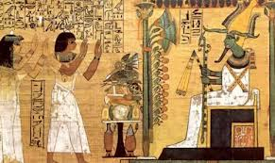picture(1)
1.2) The Japanese mythology:
Japanese Mythology is largely derived from the state religion of Shinto. (Shinto means the way of the gods. Shintoism is an Ancient religion of Japan.) The followers of Shintoism believe that spiritual powers exist in the natural world. They believe that "spirits" called kami live in natural places such as in animals, plants, stones, mountains, rivers, people and even the dead. While Buddhism has overtaken much of Japan, many people still practice Shinto, mostly for tradition rather than actual belief in the surrounding mythology.
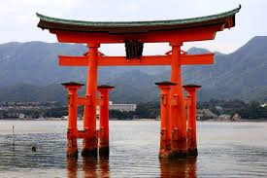 picture(2)
1.3) Mesopotamian Mythology:
Mesopotamian mythology is essentially the combination of the ancient Babylonian, Assyrian, Akkadian and Sumerian myths. Each of these peoples developed their own religions, but due to their proximity to one another, their mythology became intertwined and is collectively presented in this section. Mesopotamian mythology was also influenced by other surrounding cultures, including the Hittites and the Phoenicians. Given this diverse background, some areas of Mesopotamian myth are inconsistent, as some groups and tribes held to some of their original beliefs, while incorporating some of others.
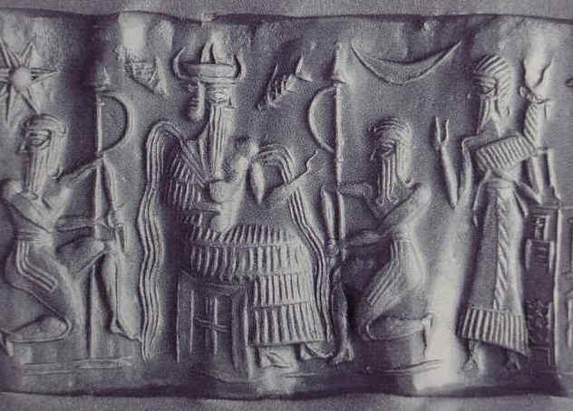 picture(3)
1.4) Roman Mythology:
Roman mythology, or Latin mythology, is a blend of ancient Greek myths and existing religions of ancient Italy, including early Roman and Etruscan civilizations. The mythology was reshaped and expanded over the years by the great population of the Roman Empire. They changed the names of the gods to make them Roman and changed some of the stories to make the gods act more like Romans. Soon they even were able to act like these had been Roman gods all along.
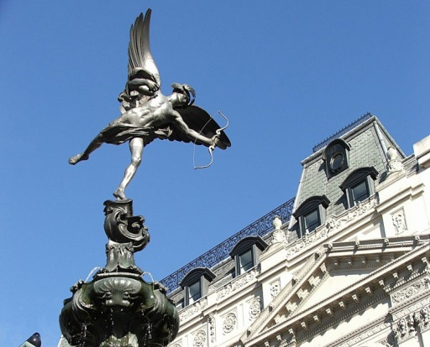 picture(4)
Example of a roman god : Cupid was the son of Venus, the goddess of love and beauty. There are myths about Cupid and his arrows. Cupid's arrows could make you fall in love.
1.5) Celtic mythology:
Unlike the well-established religions of Greece, Rome and Egypt, Celtic myth is more localized, with no universal pantheon. References have been found to over 400 Celtic gods and goddesses, many of whom were only recognized by small cults. At one time, the Celts were spread throughout Europe as far as Asia minor (modern Turkey). The Celts even occupied Rome for a time, before the rise of the Roman Empire, and although they were eventually brought into the Roman Empire, the Celtic people maintained their own religious practices even after the spread of Christianity.
The ancient Celts revered nature and the elements, and worshipped the sun, moon, the stars and the Earth Mother, with a wide range of goddesses and gods. They celebrated their deities, ancestors, life, the natural world and its creatures, and the changing of the seasons through their music, poetry, storytelling and art.
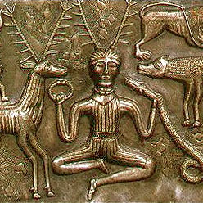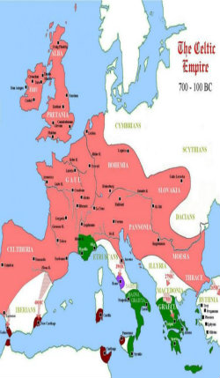 picture(5) picture(6)
1.6) The Mayan mythology:
The Maya are a native Mesoamerican civilization. Prior to the arrival of European explorers and conquerors, the Mayan civilization extended from southern Mexico across Central America, with heavy concentration in the Yucatán Peninsula.
The Maya believed in a large number of nature gods. Some gods were considered more important and powerful than others.
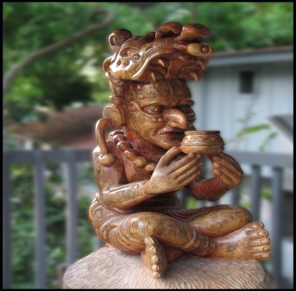 picture(7)
Itzamna - The most important Maya god was Itzamna. Itzamna was the god of fire who created the Earth. He was ruler of heaven as well as day and night. The Maya believed that he gave them the calendar and writing. It is thought that his name means "lizard house".
1.7) The Norse Mythology: (also Germanic, Nordic or Scandinavian Mythology)
Is the mythology of Scandinavian peoples. Like many ancient mythologies, the Norse myths were handed down verbally for many years. Most of our understanding of Norse myths comes from later recordings of the stories into written word.
The Norse people considered two major classes of gods: the Æsir and the Vanir, as well as several other mythical beings, including giants. Norse Mythology centers largely around the approaching catastrophic doom of the gods, Ragnarok. All the Norse gods know that Ragnarok is coming. They know what will happen, that they (and their enemies) will die. Norse Mythology is somewhat unique in this respect.
1.8)Greek mythology:
The ancient Greeks created a vast mythology which has found its way into the western psyche, and much of popular culture. The numerous stories surrounding mythological figures in ancient Greece shaped the lives of the people of ancient Greece, and later Rome. Greek mythology is sometimes known as Classical Mythology, especially when referred to in conjunction with Roman myths.
2) Why is Greek mythology famous?
2.1) Greek mythology is amongst the most well-known and well-remembered set of myths. The mythology was told and retold, and also expressed through artwork. Sculptures, vases, and various other forms of artwork were created by the people of ancient Greece in order to show their appreciation to the gods and goddesses, or to tell the stories.
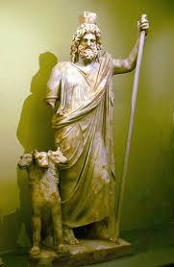 picture(8)
For example : Hades, king of the dead and the underworld and The three headed creature is called Cerberus, a large three-headed hound outside the gates of Hades (the misty and gloomy underworld, the abode of the dead), permitting anyone to enter but none to leave.
3) The Origin of the Greek Myths:
The oldest sources of Greek Mythology are the two epic poems written by Homer: the Odyssey and the Iliad although the origins of the world and the vast effort to explain the nature, the surroundings and the very essence of Greek mythology itself, lies at the texts of Hesiod, especially Theogony.
Later, hymns, poems, tragedies, plays, arts, artists, everyone tried to explain and reproduce the myths about the Gods, about heroes such as Hercules, about important kings, such as Minos, about the wars of the gods, the wars of the people.
3.1)The Odyssey by homer:
The Trojan War was over. The clever Greek Odysseus had tricked the enemy into bringing a colossal wooden horse within the walls of Troy. The Trojans had no idea that Greek soldiers were hidden inside, under the command of Odysseus.
The Greeks had been laying siege to Troy for nine long years, but suddenly it looked like their whole army had departed, leaving the horse behind.
That night, while the Trojans slept, Odysseus and his men emerged from the horse's belly. Opening the city gates, they admitted their comrades, who had snuck back in the dark.
Troy was sacked and the Trojans utterly vanquished. Now it was time for Odysseus and his fellow warriors to return to their kingdoms across the sea. Here begins the tale of the Odyssey, as sung by the blind minstrel Homer. Years after the end of the Trojan War, the Greek hero Odysseus still hasn't come home. Most people figure he's dead. But he was being held as a willing on the island of the nymph calypso. And sea god Poseidon is ticked off at Odysseus, and sees no reason to let him get home, and the epic goes on ….
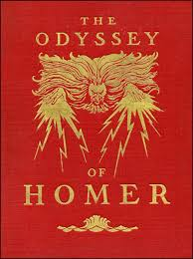 picture(9) 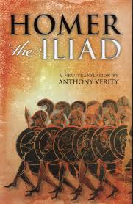 picture(10)
3.2)The Iliad by Homer :
Homer's Iliad is the stuff of legend and is focused around the Trojan wars. The Iliad tells the story of the last years of the Trojan War. The city of Troy has been under attack from the Greek armies, led by Agamemnon, for almost 10 years. It started after Paris of Troy stole Helen from her husband Menelaus (king of Sparta). The two secretly returned to Troy together and Agamemnon, the brother of Menelaus, rallied the Greek armies of his allies and went to Troy in order to seek revenge. The Iliad covers only 45 days of the conflict.
3.3) The Theogony by Hesiod:
"Theogony" means origins of the gods and Theogony is mainly about how the Olympian gods came about. After a long imploring of the muses, it starts with the forming of the world from Chaos, which at the time meant the gap separating Heaven and Earth. Out of Chaos, came Nyx (Night) and Erebus (Darkness). Also from Chaos - Eros (Love), Gaea (Earth) and Tartarus(Hell) came into being. It was Eros that made it possible for propagation between two beings – to produce offspring.
By her brother Erebus, Nyx became mother of Aether (Upper Air) and Hemera (Day).By herself, Nyx became mother of several abstract personifications: Thanatos ("Death"), Moros ("Doom"), Hypnos ("Sleep"), the Fates or Moerae and Nemesis.
Gaea, by herself, bore Uranus (Sky), Ourea (Mountains) and Pontus (Sea).
Gaea mated with her son Pontus and she became mother of two ancient sea-gods, Nereus and Phorcys, as well as Thaumas, Eurybia, and the sea monster Ceto.
Gaea married her other son, Uranus, and he became ruler of the universe. Gaea became the mother of the Titans, Hecatoncheires (Hundred-Handed) and Cyclops (Wheel-eyed). The birth of their children resulted in a war by the gods that lasted for generation.
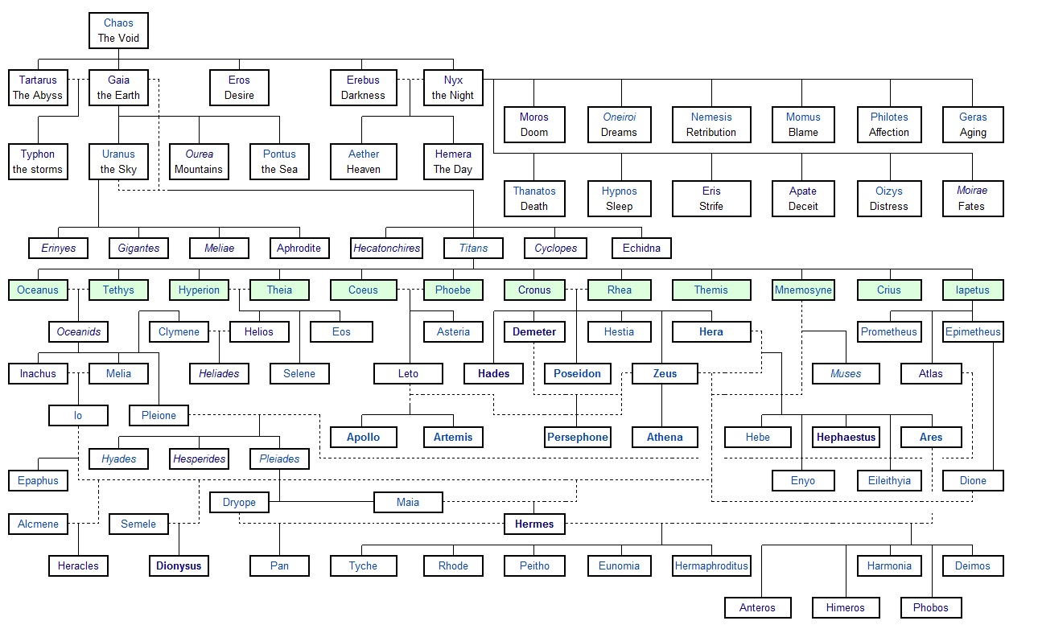
picture(11)
4) The Ages of Man according to the Greek
In Works and Days Hesiod divided time into five ages: the Golden age, ruled by Cronos, when people lived extremely long lives 'without sorrow of heart'; the Silver age, ruled by Zeus; the Bronze age, an epoch of war; the Heroic age, the time of the Trojan war; and lastly the Iron age, the corrupt present.
4.1) The Golden age:
This was the Age of the first race of mortals, who were dubbed by Hesiod “the golden race”. This golden race was created by the gods. The Golden Age was populated by men who did not grow old, and lived during an era of endless abundance and prosperity. Since they were mortals, however, in time the members of the golden race died peaceful deaths. After death, the golden race continued to wander the earth as benevolent spirits.
4.2) The silver age:
Following the Golden Age was the Silver. As the Golden Age had its golden race, the Silver Age had its silver race. Hesiod characterizes this second, silver race as “a much worse one” compared to the previous golden children of gods
(Less noble in spirit and in body was the Silver Race, and the seasons that visited them were less gracious. In the time of the Silver Race the Gods made the seasons--summer and spring, autumn and winter. The men of the Silver Race knew parching heat; they knew the bitter winds of winter, and snow, and rain, and hail. It was the men of the Silver Race who first built houses for shelter. They lived through a span of life that was longer than our span, but it was not long enough to give them wisdom. Children were brought up at their mothers' sides for a hundred years, playing at childish things. And when they came to years beyond a hundred they quarreled with one another and they did not know enough to give reverence to the immortal Gods). The silver race was characterized as foolish and immature. However, their fatal flaw was much worse - they refused to worship the gods and goddesses. This was enough to anger Zeus, and so he destroyed the silver race of mortals. Their spirits stay in the Underworld, and they are called by men the blessed spirits of the Underworld.
4.3) The Bronze age:
The bronze race was the successors of the silver, and had become far more violent. Hesiod says of the bronze race: “Black Death claimed them for all their fierceness, and they left the bright sunlight behind them”. Essentially, these mortals destroyed each other with their weapons of bronze. And so they passed away; they went down under the Earth and they left no name that men might know them by.
4.4) The Heroic age:
The fourth Age features a race that is composed of heroes, who Hesiod describes as “better and more just”. This is the Age of Heroes, and not just heroes - demigods as well. The Works and Days include references to some of the legendary men who fought in the Trojan War. It is worth noting that this is the only Age not associated with a type of metal.
4.5) The Iron age:
Hesiod names this, the fifth and last race of men he lists in his Works and Days the race of iron, and counts himself among its number, for his was the Age of Iron. It is a time of turmoil, and strife, and sadness for mortals.
The gods created the race for humans. The humans don’t have the justice that was amongst the men of the Golden Race; we have not the simpleness that was amongst the men of the Silver Race, nor the great strength that the men of the Bronze Race possessed. We are of iron that we may endure. It is our doom that we must never cease from labor and that we must very quickly grow old.

5) What are the Types of Greek Myths?
5.1) Myths of origin:
Myths of origin represent an attempt to render the universe comprehensible in human terms. These myths normally tell of how the gods created the world and mankind. There are some common stories of how the gods were themselves born, their wars against the elder gods. For example: the poem of Hesiod “The Theogony”
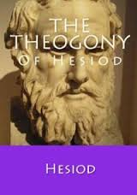picture(12) 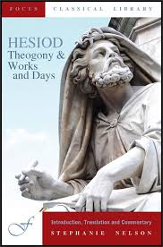 picture(13)
5.2) Myths of Ages of the World:
Are the myths that talk about the eras of the earth in certain times. Such as “The Work and Days” by Hesiod.
5.3) Myths of Gods:
Myths about the gods described their births, victories over monsters or rivals, love affairs, special powers, or connections with a cultic site or ritual.
For example: (Myth of Narcissus) Narcissus, an exceedingly handsome young boy, was the son of a blue nymph and a river god. While hunting in the forest he heard footsteps; but, he did not see a nymph named Echo. When he asked who was there, Echo's reply was the same as what he asked. When she embraced Narcissus, he pulled away abruptly and walked away. She felt crushed and heartbroken. She prayed to Venus, the love goddess, to avenge Narcissus' rejection. As punishment, Venus made Naricssus fall in love only with himself.
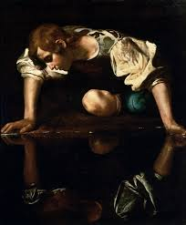 picture(14)
5.4) Myths of heroes:
Hero myths included elements from tradition, folktale, and fiction. Events described in the Iliad probably owe far more to Homer’s creative ability than to genuine tradition. Even heroes like Achilles, Hector, or Diomedes are largely fictional, though doubtlessly based on legendary prototypes. The Odyssey is the prime example of the wholesale importation of folktales into epic.
5.5) Myths of seasonal renewal:
Certain myths, in which goddesses or heroes were temporarily incarcerated in the underworld, were allegories of seasonal renewal. For Example:
Demeter and Zeus had a child, Persephone. Persephone was beautiful, and the minor deity of spring. One day, while she was out in the forest she wandered away from her mother and Hades spotted her. He was so taken by her beauty that he kidnapped her, and brought her to the underworld, either by swooping down in a chariot and grabbing her or having the earth open and swallow her hole.
When Demeter realized her daughter was missing, she began to worry, and when she couldn't find her she began to neglect her duties to taking care of the earth. The leaves of the trees began to fall off and die, flowers stopped blossoming, etc, as she traveled the world looking for her daughter. By then, Zeus realized that something must be done. Helios, a god of the sun, shared that he had seen Hades kidnap Persephone.
Demeter demanded her back but there was a catch. During her time in the Underworld, Persephone had eaten one pomegranate. If a person eats a single bit of food while they're in the Underworld they must stay there forever. However, Persephone said she had really just been thirsty and had drunk the juice from the fruit, and only swallowed six seeds. Hades claimed her as his Queen, but Zeus ruled that she would spend six months in the Underworld with Hades for the six seeds she had swallowed, and six months with Demeter outside of the Underworld.
Whenever Persephone returned to her mother, the earth began to thrive again, (spring and summer), because they were both happy, and Demeter was able to work. However, despite the deal and the promised return of her daughter, Demeter couldn't stand to have Persephone away from her for six months, and once again neglected her duties so she could search for the entrance to the Underworld to see her .This lead to fall and winter. The story of Persephone and her mother was used to explain the change of seasons.
5.6) Myths involving animal transformation:
Many Greek myths involve animal transformations. Gods sometimes assumed the form of beasts in order to deceive goddesses or women. Zeus, for example, assumed the form of a bull when he carried off Europa, a Phoenician princess, and he appeared in the guise of a swan in order to attract Leda, wife of a king of Sparta.
5.7) other types:
Other types of myth exemplified the belief that the gods sometimes appeared on Earth disguised as men and women and rewarded any help or hospitality offered them. For example:
Baucis and Philemon, an old couple from the land of Phrygia*, showed hospitality toward the gods and were rewarded. According to Greek myth, the gods Zeus* and Hermes* assumed human form and visited earth disguised as poor travelers. When they reached Phrygia, they looked for shelter but were turned away by everyone except Philemon and his wife, Baucis. The old couple gladly shared their small amount of food and wine with the strangers. Baucis and Philemon realized that their guests were gods after noticing that the wine jug never ran out and that their poor wine was replaced by wine of the finest quality. Zeus and Hermes led the couple to a hill above Phrygia and sent a flood to destroy the land to punish the people who had turned them away. Only the old couple's house remained undamaged. Zeus made the house a temple to the gods and awarded Baucis and Philemon two wishes: to serve as priest and priestess of the temple and, when the time came, to die together. Many years later, when the moment of their deaths came, Baucis and Philemon were transformed into trees with intertwined branches.

Conclusion
Well you can’t say they were right or they were wrong. It depends on who you are asking.
For example: if you asked a Greek man of that era he will tell you they were true, they build temples for them and they worshiped there gods and goddesses. They dedicated their lives to be priests and priestesses. The people believed their crops, their marriages, their children's lives revolved around the gods and goddesses being happy.
Just like Islam, Christian, and Jewish you can’t really prove there god exists yet you still believe in him, pray to him, and worship him.
All religions are real to its believers. However, since we call them myths, it denotes that we do not consider them real.
Although we didn’t believe in the Greek mythology they still impacted our societies today such as:
The Olympic Games are an example of a common, modern influence directly related to Greek mythology. The Olympic Games occur once every four years, and they originated in Greece. These games were held in honor of Zeus. The prizes for winning these games were the fame and glory, also the winner’s faces are put on coins. Today, we still celebrate the Olympic Games, and many things are similar, like olive leaf crowns and the opening and closing ceremonies.
Greek mythology impacts our entertainment industry. There are multiple movies on mythological characters. For example, the movies “Hercules” and “Percy Jackson and The Lightening Thief” show the influence of mythological stories on the modern population. These movies educate people on Greek mythology, while keeping them entertained.
Greek mythology has influenced our science quite heavily from the very start – including the naming of the planets. The first five planets (not including Earth): Mercury, Mars, Venus and Saturn were all named by the Romans after adaptations of what were originally Greek gods. Mercury is the roman equivalent of Hermes the messenger of gods and was named for the speed with which the planet moves around the sun. Mars, known for its red color was named for the Roman equivalent of the Greek god Ares, the god of war. There is a similar pattern for Venus, Saturn and Jupiter who have all been named after the Roman equivalent of the Greek gods Aphrodite, Kronos and Zeus. The last three planets, discovered with the invention of telescopes were named in a similar matter to….

Photo Index
Pic 1 | This pic shows how the Egyptians worshiped gods with animal faces
Pic 2 | The Shinto
Pic 3 | Some of the runes of the Mesopotamian mythology
Pic 4 | A statue of cupid
Pic 5 | This pic shows how the worshiped animals
Pic 6 | A pic that shows how the Celtic were spread in Europe
Pic 7 | Itzamna the Mayan fire god
Pic 8 | A statue of Hades
Pic 9 | Homer cover of the book “The Odyssey”
Pic 10 | Homer cover of the book “the Iliad”
Pic 11 | The family tree of the gods according to Hesiod
Pic 12 | Cover of Hesiods book Theogony
Pic 13 | Cover of Hesiods book “Work and days”
Pic 14 | A picture of Naricssus to show how he fell in love with his self when he saw his reflection

References
- http://www.dl.ket.org/latin/mythology/whatisa.htm 9:53 am 28/12/2014
- http://dictionary.reference.com/browse/mythology 10:30 pm 28/12/2014
- http://examples.yourdictionary.com/myth-story-examples.html 11:08 pm 28/12/2014
- http://www.greekmyths-greekmythology.com/greek-mythology 4 pm 28/12/2014
- http://www.mythweb.com/odyssey/ 4:30 pm 28/12/2014
- http://www.artble.com/artists/john_flaxman/drawings/the_iliad/more_information/story-theme 5:00 pm 28/12/2014
- http://www.editoreric.com/greatlit/books/Theogony.html 5:20 pm 28/12/2014
- http://www.timelessmyths.com/classical/creation.html#Hesiod 5:30 pm 28/12/2014
- http://www.ancient-mythology.com 12 pm 29/12/2014
- http://www.uri.org/kids/other_shin.htm 12:11 pm 29/12/2014
- http://rome.mrdonn.org/romangods/cupid.html 3 pm 30/12/2014
- http://www.mauiceltic.com/celtic-beliefs.htm 3:10 pm 30/12/2014
- http://www.ducksters.com/history/maya/religion_and_mythology.php 3:20 pm 30/12/2014
- http://www.sacred-texts.com/cla/hesiod/ 2 pm 31/12/2014
- http://www.sacred-texts.com/etc/omw/omw31.htm 3 pm 31/12/2014
- http://www.mythography.com/myth/mythology-five-ages-of-man-according-to-hesiod/ 2:10 pm 31/12/2014
- http://www.britannica.com/EBchecked/topic/244670/Greek-mythology/65488/Religious-myths 4 pm 31/12/2014
- http://www.mythencyclopedia.com/Ar-Be/Baucis-and-Philemon.html
6 pm 31/12/2014

http://www.dl.ket.org/latin/mythology/whatisa.htm
http://dictionary.reference.com/browse/mythology
http://www.ancient-mythology.com/egyptian/
http://www.uri.org/kids/other_shin.htm
http://www.ancient-mythology.com/japanese/
http://www.ancient-mythology.com/mesopotamian/
http://www.ancient-mythology.com/roman/
http://rome.mrdonn.org/myths.html
http://rome.mrdonn.org/romangods/cupid.html
http://www.ancient-mythology.com/celtic/
http://www.mauiceltic.com/celtic-beliefs.htm
http://www.ancient-mythology.com/mayan/
http://www.ducksters.com/history/maya/religion_and_mythology.php
http://www.ducksters.com/history/maya/religion_and_mythology.php
http://www.ancient-mythology.com/norse/
http://www.ancient-mythology.com/greek/
http://examples.yourdictionary.com/myth-story-examples.html
http://www.greekmyths-greekmythology.com/greek-mythology
http://www.mythweb.com/odyssey/
http://www.artble.com/artists/john_flaxman/drawings/the_iliad/more_information/story-theme
http://www.timelessmyths.com/classical/creation.html#Hesiod
http://www.sacred-texts.com/cla/hesiod/
http://www.mythography.com/myth/mythology-five-ages-of-man-according-to-hesiod/
http://www.sacred-texts.com/etc/omw/omw31.htm
http://www.mythography.com/myth/mythology-five-ages-of-man-according-to-hesiod/
http://www.mythography.com/myth/mythology-five-ages-of-man-according-to-hesiod/
http://www.mythography.com/myth/mythology-five-ages-of-man-according-to-hesiod/
http://www.sacred-texts.com/etc/omw/omw31.htm
http://www.britannica.com/EBchecked/topic/244670/Greek-mythology/65488/Religious-myths
http://www.mythencyclopedia.com/Ar-Be/Baucis-and-Philemon.html

