تقرير حلقة بحث بعنوان :

TANGO DANCING

تقديم الطّالبة: هبة حيدر
الصّف: العاشر
تاريخ: 29/12/2014
إشراف المدرّسة: صبا منصور
Tango Dancing
Chapter one
What is tango dancing 3

The history of tango 4

Influence of tango 6
Chapter two
Styles of tango dancing 8

Music for tango 10

References 11

CHAPTER ONE :
What is Tango Dancing ?
Tango is a beautiful dance between two people who have a strong connection between each other, it is danced in both styles "modern and traditional".

In Tango dancing there is a 'leader' and a 'follower',, the leader gives the follower invitations to know when and where to dance,, and the follower decides in what way he will accept the leader's invitations.

Then they both try to maintain harmony and connection through the embrace,, and so the dance is born.

Tango today is an international dance, so in many countries around the world you will find at least one tango club!!.

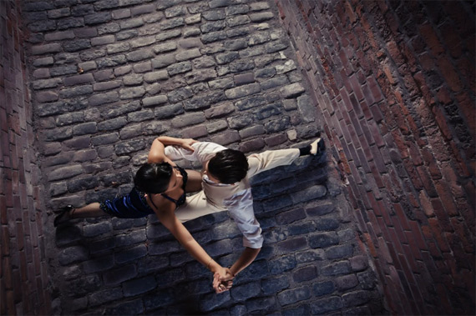

The history of Tango :
The deep roots of Tango lie in African slavery.
The Tango is a mixture of strange dances of Blacks in Haiti, Cuba and Argentina.
Tango was first danced before the 1st World War in Europe. And actually its origin is from Argentina,, then a popular dance called "Habanera Del Café" appeared during the Spanish American war, it was the primative tango!!

Tango was popular for poor people who used to dance it in streets but after a period of time it turned into an international dance and people gave lessons about it!!
In 1907 tango was performed in France then it was spreaded to the other capitals and countries of Europe,, as a result it became very famous in France and England.
In 1913 it was danced in the USA for the first time and was known in Fenland.

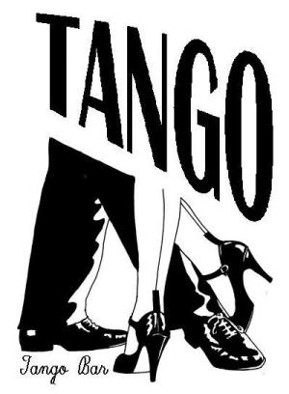

Influences of Tango :
These days the influence of Tango is obvious in many activities like swimming and gymnastics, because of that the dramatic feelings have been integrated very well in them.
Tango dancing has helped many people to perform the best of what they have in front of people!
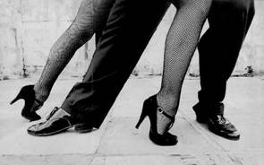
That the goal of any dance is to tell a beautiful compelling story to the audience, putting in mind the things that bring life to the dance which are passion, integrating in the dance and the beautiful expressions.

Tango has another influence concerned in the health field !!
It has helped many people who have "Parkinson's disease" because of the several types of movements it contains, just like turning and dynamic balance .
And many researches said that it leads the heart to a better health, better balance, and it improves the memory.

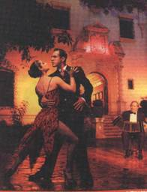

CHAPTER TWO :
Styles of Tango Dancing :
Different styles of tango has developed in Argentina and other countries, here are the most popular styles of it:
~Argentine Tango.
~American Style Tango.
~International Style Tango.

Argentine Tango :
It is also known as the Arrabalero Tango, and the word 'Tango' came from the Gauchos in Buenos Aires! It originated in the West Indies. And just poor people used to dance it.

American Style Tango :
This style is structured to the music, and it incorporates a particular freedom of
expressions that are not presented
in the International style.

International Style Tango:
It is stricter than the American style, and we can find it in competitions and festivals.

Some other styles:
Tango Oriental – Tango Salon -
Show Tango (Fantasia)
And a style that has appeared lately is Tango Nuevo or "New
Tango" it was made by the
youngest group of dancers!. The beautiful thing about it is that it is related to people who like jazz and techno music!.

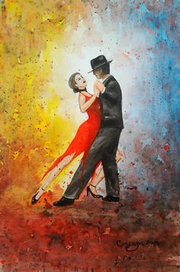
Music for Tango :
For a beautiful tango dance, dancers should choose the best music for their performance, that their choice is considered as their first challenge! However, their second challenge is knowing from where to buy it!
Between the late 1930s and the early 1950s the best music for tango was played, and this period is called "the Golden Age of Tango" so when they will look for the best music they should start with the four great orchestras of the golden age which are : D'Arienzo, Di Sarli, Troilo and Pugliese.
Then, they can move on to the other major orchestras like:
Caló, Tanturi and De Angelis.
And when they want to have the records they'd better go and search them online !

Finally, their guide should be their ears, sense of rhythm and style.

References

~http://www.dancelovers.com/tango_history.html

________________________
~http://www.beyondtango.com/

~Hiba Haydar

