Syrian Arab republic
2014-2015
Ministry of education
The national center for distinguished

The genetic engineering
An English Seminar

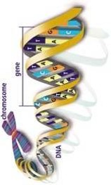
AL-HUSSINE AL-AKRAA
TEACHER: MIRNA SMAAN
ELVENTH GRADE

Contents

Introduction
Chapter 1: the genetic engineering
S 1: the nucleus and the nucleic acid
S 2: the genetic engineering
S 3: the genetic engineering techniques
S 4: the history of the genetic engineering
Chapter 2: the application of the genetic engineering
S 1: the cloning
S 2: the genetically modified food
S 3: the genetic fingerprinting
S 4: other application
Figures tablet
references

Introduction

Everywhere in our life, we listen and read about the genetic engineering. The new science that all the world go to study and work at it.
Why when we hear "cloning" or modified organism, immediately we think about the genetic engineering.
So, what is the genetic engineering? Moreover, what the relationship between the cloning, modified organism and the genetic engineering?
This seminar is to answer these questions. So, what is the answers.
Chapter 1: genetic engineering:
Section 1: The nucleus and nucleic acid:
1-1: the nucleus:
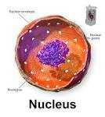
Figure 1
It is the most important thing in the cell. Robert Brown discovered it in 1831.
The nucleus have several form like Spherical, Fusiform, and Lobular.
It located in the middle or in the top of the cell.
1-1-1: the importance of the nucleus:
1-it supervise the biochemical processes in the cell.
2-it considered the store of DNA.
3-it is responsible for the continued development and cellular differenation.
4-it control the shaping, copying, and transferring the genetic traits.
1-1-2: the structure of the nucleus:
The nucleus consist of four section:
1-Nuclear envelope: it is in eukaryotes cell and it lacking in prokaryotes. It consists of two envelope, one of them is external, the other is internal, and there is a space between them. Its thickness is about 10-40 nm. The envelope is with holes that allow the contact between the nucleus and the cytoplasm.
It has two job:
1-ensure the continuity the exchanges between the nucleus and cytoplasm.
2-contribute to the installation of some vehicles like proteins.
2-Nuclear plasma.
3-Nucleoius: they are balls in the nucleus and its jobs are:
1-made proteins and RNA.
2-a store for RNA's kind.
4-Chromatins: they represent the nuclear genetic material. They consist of 30% DNA and little of RNA and two kind of proteins. It has two function:
1-preserving the genetic material stocks.
2-building the genetic traits.
1-2: The nucleic acids:
Mistcher discovered them in 1871. Then, the scientists discovered that the DNA is the responsible for the genetic things in the body.
There are two kind of nucleic acids:
1-DNA 2-RNA
1-2-1: DNA: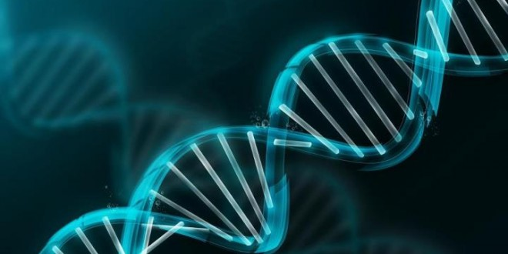
Figure 2
The DNA consists of:
Sugar (deoxyribose) + Phosphate group + Nitrogen base.
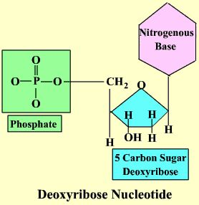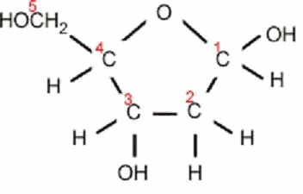
Figure 4
Figuer3
There are two kind of nitrogen base:
1-purines: a nitrogen base that has a double-ring structure. They are two: Adenine and Guanine.
2-pyrimdine: a nitrogen base that has a single-ring structure. They are two: Thymine and Cytosine.
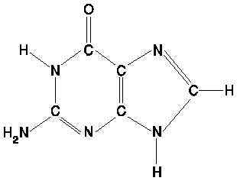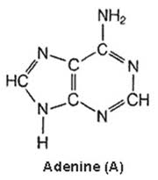
Figure 6
Figure 5
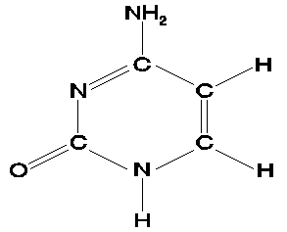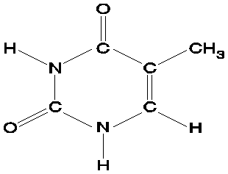
Figure 8
Figure 7
Each one of them pairs with other that mean adenine pairs with thymine and guanine pairs with cytosine.
Spectroscopy experiments are proved that the DNA molecule is shopped like a spiral staircase and is composed of two parallel stands of linked submits.
1-2-2: RNA:

The RNA differs from DNA in three ways:
1-the RNA composed of one strand of nucleotides rather than two strands.
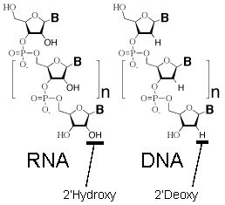
Figure 9
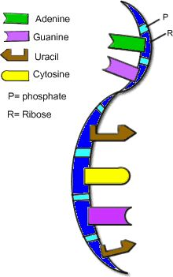
Figure 10
2-the RNA's nucleotides contain the five-carbon sugar ribose rather than the sugar deoxyribose. That means ribose have one more oxygen atom than deoxyribose.
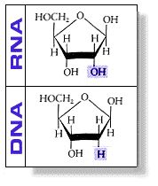
Figure 11
3-the RNA nucleotides have a nitrogen base called Uracil instead of thymine.
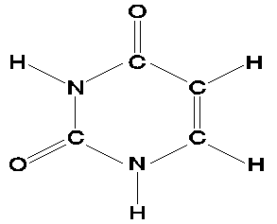
Figure 12
There are three kind of RNA. They are:
1-Messenger RNA: (mRNA)it carries instructions for making proteins from genes and deliver them to the site of translation.
2-Transfer RNA: (tRNA) it reads the mRNA sequence.
3-Riboseomal RNA: (rRNA) the RNA is found in ribosomes.

Section 2: The genetic engineering:
The genetic engineering became one of the easiest and the most useful science from 1970 until now, that mean making copies from any gene or any piece of DNA is very easy and they can restore it to the cell and integrate it with the chromosomes.
The genetic engineering is a process of copy, adjust, and plant the genes in the body.
The genetic engineering concepts:
- The ability to isolate the gene of an organism and move it to another, that mean creating of plants and animals possess desirable qualities.
- Taking recipes from the cell and transplanted into another cell.
- Adjust and improve the organisms.
- Delete or add genes that responsible for certain genetic traits.

Section 3: The genetic engineering techniques:
The genetic engineering techniques are:
1-cut the DNA by special scissors.
2-separate the pieces of DNA on electrophoresis gel.
3-know the nuclear sequence for each DNA.
4-hybridize the DNA.
5-clone DNA.
6-adjust the DNA to give many modified versions.
The genetic engineering base on two things:
1-Nuclear enzymes:
These enzymes can cut the DNA and they are five kind:
1-enzyme HINDIII 2-enzyme HAEIII 3-enzyme H pal
4-enzyme DNA polymerized 5-enzyme linking DNA
2-The vectors:
The scientists use "gene transfer" to mean transfer gene from cell to another where they enter pieces of DNA in the DNA of host's cell by the vectors.
There are three kind of vectors:
1-Plamides: it is a small circular piece of DNA. It can multiply quickly.
2-Virus' DNA.
3-Direct injection of the DNA in the cell where they add calcium phosphate solution to the DNA.

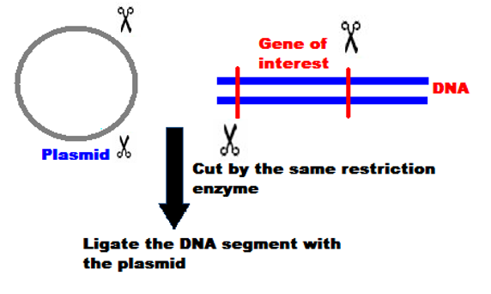
Figure 13
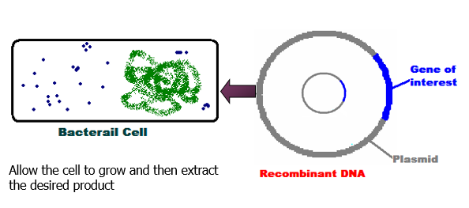
Figure 14
Section 4: The history of genetic engineering:
1866: Mendel did many experiences on peas plants.
1900: The scientists rediscovered Mendel's rules.
1903: Scientists said that the genes are on the chromosomes.
1910: Scientists proved that the genes are on the chromosomes.
1918: "Biotechnologies" as term was found.
1922: The first gene map for Drosophila.
1928: Genetic transformation experiences.
1933: The first science fiction story about genetic engineering. Its name was "brave new world".
1938: "Molecular biology" as term was found.
1944: The scientists proved that the genes are composed from DNA.
1948: "Chemical engineering" and "Molecular medicines" as terms were found.
1953: The scientists discovered the installation of DNA.
1960: The scientists discovered RNA.
1973: The scientists isolated the gene for the first time.
1977: "Genetics" was found. It was the first company that worked at genetic engineering.
1978: The scientists produced the human insulin.
1982: the first factory that produce the insulin from genetic engineering was built in London.
1985: discover the DNA fingerprint.
Then the scientists produced many animals and plants genetically modified.

Chapter 2: THE APPLICATION OF GENETIC ENGINEERING:
Section 1: cloning:
Figure 15
1-1: what is the cloning?
The cloning is a creation of a living organism as a copy of another person's genetic and physiological characteristics.
It is etheogeusis (no sexual reproduction) mean there is not father for the cloned organism.
1-2: the kind of cloning:
1-Genes cloning:
The cell is consisted of thousands of genes. We clone genes for study it or its characteristics or use it for product proteins. This process is one of the easiest and most useful in this day.
2-Cells cloning:
It means product thousands of cells from one cell. For accomplish this goal, the cell that we want to study it, is isolated and we leave it to divide and give many cells that look like the first one.
3-Organisms cloning:
4-Human cloning:
There are two kind of human cloning:
A-Reproductive cloning: it aims to clone the human, but it is not acceptable from the scientist.
B-therapeutic cloning: it aims to formation of stem cells.
1-3: method of cloning:
1- Taking the genetic material of the cell.
2- Take an egg from ovary and dump it from its genetic material.
3- Enter the genetic material from the first cell in the egg.
4- Put the cell (egg)in a test tube.
5- Finally, take the egg and put it in womb.
1-4: how the scientists clone "Dolly":
1- The scientists took 277 eggs from lamb's ovary. Then, they emptied them from their nucleus.
2- They took cells from another lamb and they took their nucleus and put it in the first cells.
3- They shocked them, so the fusion happened in 29 cells.
4- They put each cell in a lamp womb and from 29 cells, one cell stay alive.
5- In July 1997, Dolly was born.
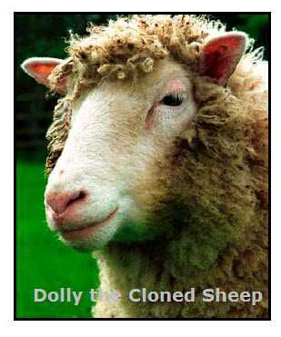
Figure 16

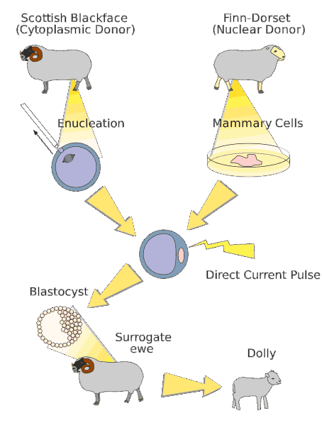
Figure 17

1-5: advantages:
1-clone members for damaged bodies.
2-propagtion of transgenic animals.
3-preservation of rare and endangered animals.
1-6: disadvantages:
1- The cloning depends on one cell. What happened if this cell is infected with aging or cancer?
2- Disorder in male and female numbers.

Section 2: the genetically modified food:
The genetically modified food called biotechnology. It modified the genes of plants to give it desirable qualities.
2-1: the history of biotechnology:
Lot of us think that the biotechnology is very modern, but the truth, it is very old. The old Egyptians used different kind of yeast to make bread and alcoholic beverages.
2-2: why do we need to improve plants?
We improve plants to increases its output and its resistance to diseases and pesticide. Moreover, to improve the environment and reduce water use.
2-3: what is the first modified food?
In 1983, the scientist adjust the tobacco plants. It was the first modified plant. Then in 1994, the first modified food was sold in USA. It was tomato.
2-4: what are the modified crops that the human plants?
There are soybean (41%), corn (47%), cotton (8%), canola (3%), and other like trefoil, squash, tomato, banana, potato, rice and pepper.
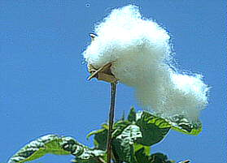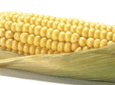
Figure 18
2-5: the leader countries in planting modified crop:
In Asia, China and India are the leader. In South America, Brazil and Argentine are the leader. South Africa is in Africa. However, the USA are the leader in the world.
This table show the countries that use modified crop.
Number of crop | country
50 | USA
30 | Canada
22 | Japan
9 | EU
3 | Argentine

2-6: advantages:
1- Better usage for pesticide.
2- Plants can bear the drought and soil salinity.
3- Improving food awareness.
4- Fruit and vegetables more useful.
2-7: how do we adjust the plant?
We adjust the plant by the disposition of the genes. The disposition is separation, installation and rebuilding the DNA chains. That mean we4 take the gene that we want and put it in the genes of the new plant.
2-8: how do the modified corn differ from the regular one?
The modified corn can kill three kind of harmful insects by product a protein kill these insects. Bacteria called "bacillus thuringiensis" produce this protein naturally.
2-9: disadvantages:
There are not any disadvantages in this day.However, there are many doubts.

Section 3: the genetic fingerprinting:
The genetic fingerprinting mean the order of DNA characteristic of each person. The human have the same genes but in different order.
How we discover the DNA fingerprint?
1- pattern: we put it in a plastic tube. They take them from hair or the white blood cells.
2- Cut and partition: there are special enzymes called "restriction endonuclease". They can cut the DNA to small pieces.
3- transfer: we take a plastic leafs, then they put the pieces of DNA on this leafs.
4- Probe and examination: they add radiant materials, and then the DNA will be colored.
The usage of this technology:
1- Determination of persons.
2- Determination of paternity.
3- animals classification.

Section 4: Another application:
1-1: the medical field:
1-the scientists produced the human insulin.
2-they produced human growth Harmon for treatment of short stature.
3-they produced blood clotting factors.
4-they produced vitamins like B2, B12, C, D, K……
5-they produced "fdlitropin beta" that it help the ovulation in the female.
6-they produced "thyrotropin" for treatment of thyroid cancer.
7-they produced "alteplase" for treatment of blood clots.
8-they produced "epoetin alfa" for treatment of anemia.
9-they produced "avastin" for treatment colon cancer.
10-they produced "interferan alfa" for treatment of blood cancer.
11-they produced many medicines for hepatitis and flu.
12-they produced cartilaginous, bone and leather tissues.
1-2: the military field:
1-producing wheat grains with sick genes.
2-development of biological weapons to attack specific ethnic groups.

Figures tablet
page | description | figure
4 | nucleus | 1
5 | DNA | 2
5 | Deoxyribose nucleotide | 3
5 | deoxyribose | 4
6 | guanine | 5
6 | adenine | 6
6 | cytosine | 7
6 | thymine | 8
7 | DNA & RNA | 9
7 | RNA | 10
7 | five-carbon sugar ribose and deoxyribose | 11
8 | uracil | 12
11 | The genetic engineering techniques | 13
11 | The genetic engineering techniques | 14
13 | cloning | 15
14 | dolly | 16
15 | How the scientists clone dolly? | 17
16 | Cotton & soybean & corn | 18

References
1. Abrams, N.: «Medical Ethics: A Clinical Text-book», A Bradford book Massachus. 1983.
2. Anderson, J.K.: «Gen etic Engineering», Zondervan Publishing, House, Michigan, 1982.
3. Aridity,«Test-tube Women-What Future for Motherhood, Pandora Press, London. 1984.
4. Arras, J.: «Ethical Issues in Modem Medicine»2nd Ed, Mayfield, Publishing Company, California,
1983.
5. Autton, N.: «Doctors talking», Moubray and Co. Ltd., and London. 1984.
6. Beauchamp, T.: «Principles of Biomedical Ethics»Oxford University Press, Oxford, 1983.
7. Bernal, D.: «Science in History», Vol. 3, A Pelican Book, England. 1969.
8. Busied, J.: «Health & Human Values», Yale University Press. New Haven 1983.
9. Campbell, A.: «Moral Dilemmas in Medicine 3rd. Ed, Churchill. Living Stone, New York, 1984.
10. Chaplain, A.L.: «The Sociobiology Debate»Harper and Row. Pul ishers, New York
11. Dampier, W.C.: «History of Science», Cambridge University. Press Cambridge 1966.
12. Donald, I.: «Test-Tube Babies-A Christian View», Backet Pub. lications, Oxford,1985.
13. Dooner, M.: «The Intellectual Tradition of the West», Scott Fors. man & Company, U.S.A
14. Fox, R.M.: «New Directions in Ethics,»Routledge and Kegan, Paul, New York. 1986.
15. Glover, J.: «What Sort of People There should be?»Penguin, Books, England. 1984.
16. Goodfield, J.: «Playing God», Random House, and New York,1977.
17. Harris, J.: «The Value of Life», Routledge & Kegan Paul, London. 1983.
18. Huxley, A.: «Brave New World», Triad Panther, and Cranade Pub- lishing Ltd., England,1984.
19. Jones, D.G.: «Brave New People», Inter-varsity Press, England. 1984 20. Lear, J.: «Recombinant
D.N.A., The Untold Story»Crown Pub. lishers, New York 1978.
21. Lewis, M. A.: «Law and Ethics in the Medical Office», F.A. Davis. Company, Philadelphia
22. Lygre, D.G.: هLife Manipulation>, Walker & Company, and New. 1979, York 1983.
23. Mc Cormick, R.A.: «How Brave A New World?»S.C.M. Press LTD, England. 1981.
24. Milunsky, A.: «Genetics & the Law II», Plenum Press, New York. 1980.
25. Nelson, «Human Medicine», Augsburg Publishing House, U.S.A. 1973
26. «Nova», Program Broadcast by Kuwait Television 2nd Program. on 25/9/1985
27. Ramsey, p.: «Fabricated Man», Yale University Press, and New. Haven, 1970.
28. Russell, B.: «History of Western Philosophy», Unwin Paperbacks. London,1980.
29. Simmons, P.D.: «Birth & Death Bioethical Decision Making», The Westminster Press, U.S.A1983.
30. Stevens, K.: «Surrogate Mother, One Woman‘s Story»Century. Publishing, London, 1985.
31. Veatch, R.M.: «A Theory of Medical Ethics»Basic Books, Inc. Publishers, New York 1981.
32. Warnaco, M.: «A Question of Life», The Wornok Report on Hu. man Fertilization & Embryology,
Basil Balackwell, Oxford 1984.
33. Winn, D.: «Baby Cotton, For Love & Money», Dorling Kindersley. Publishers, London.1985.

. Winn, D.: «Baby Cotton, For Love & Money», Dorling Kindersley. Publishers, London.1985.
The same references
. Harris, J.: «The Value of Life», Routledge & Kegan Paul, London. 1983.
. Warnaco, M.: «A Question of Life», The Wornok Report on Hu. man Fertilization & Embryology, Basil Balackwell, Oxford 1984.
. Lewis, M. A.: «Law and Ethics in the Medical Office», F.A. Davis. Company, Philadelphia
. Autton, N.: «Doctors talking», Moubray and Co. Ltd., and London. 1984.
. Dampier, W.C.: «History of Science», Cambridge University. Press Cambridge 1966.

