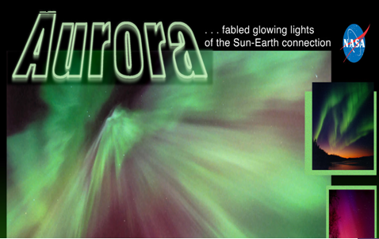

|  |
| --- |
| Year : 2014-2015 |

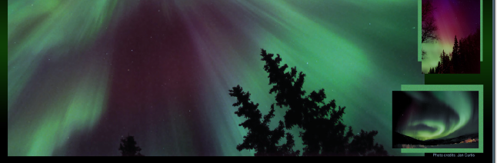

|  |  |
| --- | --- |
| **Research in English** | **Aurora…..the magical lights of the sky** |

-Presented by : Amani Shikhani

- Supervisor : teacher Bayan Al Sufi

**Preface :**

- Although our planet is very small comparing to the outer space ,but it is strongly affected by the surrounding space , and that causes many phenomenons which excite the curiosity of the scientists .

The sun is the most affective factor that affects our planet in many ways. Without the Sun, Earth's land, water, and air would all be frozen solid!. Life on Earth would cease to exist. That's because almost all creatures rely on the steady light and heat of the Sun. The Sun's heat makes liquid water on our planet possible. And all life kinds that we know—from bacteria to elephants—need liquid water to survive, but the sunlight and the heat are not the only relationship between the Earth and the sun......

-Every second, millions of explosions are happening in the sun , flinging electrified gas into space creating 'space weather'. Some of this material collides with the Earth causing many other effects.

One of these effects are the famous coloured lights of the northern and southern poles which called “Aurora “ .

Introduction :

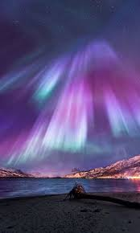_Those who live at far northern and southern latitudes on the Earth's surface usually witness a spectacular light show, this display of light called an [aurora](javascript:return%20false;). It is caused by energetic charged particles emitted by the Sun and crashed into the Earth's [atmosphere](javascript:return%20false;) near the northern and southern magnetic poles. This produces intermittent auroras in the Arctic and in the Antarctica.

These auroras are also called the northern and southern lights (or aurora borealis and aurora australis, respectively).

_The magical lights of the aurora have been enjoyed by people for millions of years ago ,and Many legends, myths and superstitions have revolved around the aurora throughout the history of mankind.

So, what is so special about the northern and southern lights that thousands of people go out of their homes to plan specific aurora vacations?, Imagine this. You look up and see the undulating, multi-colored ribbons of light dance across the sky. They display visual patterns far more intricate than the most talented artist could create.

-In this research we will discuss what is the aurora??, and how the scientists explained the cause and the different colours and shapes of this magical and surprising display of light in the sky ???!!!!!!..............

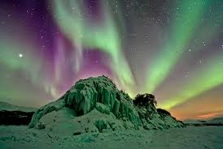- Aurora is a phenomenon that is not completely understood, it’s mysterious and unpredictable nature's light show, dynamic display of light that appears in the Antarctic and arctic sky in a specific times during the year. “An Eskimo tale describes the lights as flaming torches carried by travellers to the afterlife”[1].

But scientists say that the aurora is the name of futons which emit by the excited atoms and molecules in the atmosphere when an energetic charged electrons hit them. -Because of its bright lights, aurora got its name for the Roman goddess of dawn. These lights have many colours such as the milky greenish, auroras can also show red, blue, violet, pink, and white. these colours appear in a variety of continuously changing shapes. -Many people and tourists go to Alaska and Canada and another countries to see this magnificent display of light .As those who have witnessed the Aurora can attest :” there is no sight can equal the magic and mystery of these luminous sheets of colour undulating in the frigid air of the Antarctic winter.”

The aurora appears in varied shapes ,like the long, narrow arcs of light which often extend east to west , or stretch across the night sky from horizon to horizon, sometimes they can spread out in multi-colored rays, like vertical shafts of light that stretch far up into space, but the most beautiful and common shape of the aurora is when it takes the shape of curtains which seem to float on a breeze of light , and it usually moves up and down from side to side , which makes it looks like a dancing lights .

Dramatically different auroras can appear in a single night, and all of the shapes can vary in the intensity of light. Auroral arcs can nearly stand still and then as the night progresses, the bands and arcs become rippled and folded.... and the aurora will begin to dance and turn.

After midnight, the aurora can take on a patchy appearance and the patches often blink on and off once every 10 seconds or so until dawn.

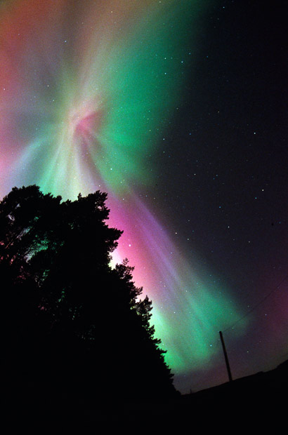

Figure ( 1) : Corona:

The corona is considered the most spectacular form of the aurora, appearing overhead with all shafts converging to a center point.

The different shapes of auroras are a mystery that scientists are still trying to unravel. The shape seems to depend on where in the magnetosphere the electrons

originate, what causes them to gain their energy??, and why they dive into the atmosphere??.....

In fact, scientists have been speculated about this for hundreds of years, because many observers said that they have heard a cracking while they were watching the aurora lights in the sky but they weren’t sure about this.

After many attempts ,some scientists said that they have been unable to detect any audible sound from the northern and southern lights, while other scientists cannot find a reason why the lights should make a sound.

Some experts said that ” the aurora doesn’t make any sound because the air in the upper part of the atmosphere where auroras are formed is too thin to conduct audible sound any distance. So if sounds are heard, they must come from some other phenomenons occurring at the same time”[2].



-The sun affects our planet in many ways , and auroras are a sign that the sun and the Earth are connected by more than sunlight, they indicate that something electric is happening in space causing these bright lights.

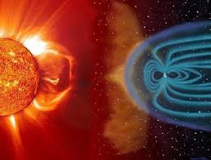The origin of the aurora is the Sun ,as far of 93 million miles (149 million km) from Earth . -Millions of different chemical reactions are happening in the sun every minute , some of these reactions causes many enormous explosions , and the sun spits millions of energetic particles and charged electrons , these particles and electrons are carried out into space along with the ever-present hot solar wind ( a stream of the electrically charged particles (mostly protons and electrons) flowing out from the Sun in all directions), This wind sweeps supersonically toward Earth at speeds ranging from 300 to over 1000 km per second, carrying with it the solar magnetic field.

figure ( 2) : *A solar storm blasts out from the Sun and heads towards Earth’s protective shield, the magnetosphere*

The solar wind distorts the Earth’s magnetic field to create the comet-shaped magnetosphere (the region of the space controlled by Earth’s magnetic field). This region stretches about 60,000 km (40,000 miles) toward the Sun and several hundred thousand kilometres in a long tail on the dark side, away from the Sun.

The terrestrial magnetic shield acts as a barrier, protecting the Earth from energetic particles and radiation in the hot solar wind. Most of these energetic particles are deflected around the Earth by the magnetosphere, but some get

trapped.

Electrons that trapped in the Earth’s magnetic field are carried along the lines of the magnetic field toward the polar regions and then strike the atmosphere .

After the electrons strike the atmosphere, they transfer their energy to the oxygen and nitrogen atoms and molecules in the atmosphere , making them “excited”.

As the gases return to their normal state, they emit photons (small bursts of energy in the form of light).

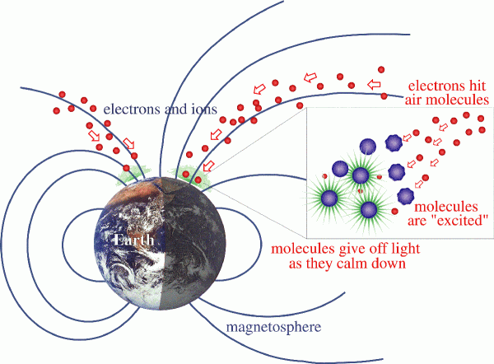

Figure ( 3) :

The energetic electrons from the space make the atmosphere’s atoms exited.

When a large number of electrons come from the magnetosphere to the atmosphere, the oxygen and nitrogen atoms can emit enough light for the eye to detect, giving us beautiful auroral displays.

“This ghostly light originates at altitudes of 100 to more than 400 km (60 to more than 250 miles).” [3]

-As we said before ,the different colours of aurora’s lights are formed when the excited atoms emit photons to return to their balanced state .

#### These colours differentiate between milky green and deep red . So , what is the reason to show these different colours ??? , why don’t aurora’s lights display with the same colour???...........

-In fact , the colour of the aurora depends on which gas

— oxygen or nitrogen — is being excited by the electrons, and on how excited it becomes. The colour also depends on how fast the electrons are moving, or how much energy they have at the time of their collisions.

Normally, if a high energy electron strikes an Oxygen atom , it emits green light –which is the most familiar colour of the aurora , while low energy electrons cause a red light.

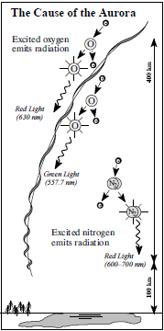Nitrogen atom usually gives off a blue light , .and the blending of these colours can lead to another colours like purples, pinks, and whites.

“Most of the auroral features are greenish yellow but sometimes the tall rays will turn red at their tops and along their lower edge. On rare occasions, sunlight will hit the higher part of the auroral rays creating a faint blue colour. On very rare occasions (once every 10 years or so) the aurora can be a deep blood red colour from top to bottom. In addition to producing light, the energetic auroral particles deposit heat. The heat is dissipated by infrared radiation or transported away by strong Figure (4) : The cause of the winds in the upper atmosphere.” [4] different colours of the aurora

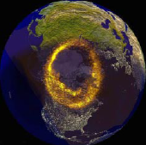-Aurora usually appears in oval-shaped rings known as **auroral ovals ,** this rings extend approximately 4000 km in diameter .The northern oval traces a path across central Alaska , Canada, Greenland, northern Scandinavia and Russia.

Figure ( 5) : UV image of auroral oval superimposed on a gure of partly sunlit Earth

The auroral oval in the hemisphere extends on the ranges of the oceans circling Antarctica , and it can reach the far edges of New Zealand, Chile, and Australia.

-Many people think that auroras can only be seen in the poles of the Earth, but auroras are actually quite rare at the geographic and geomagnetic poles.

In fact, auroras are usually seen in the surrounding region around northern and southern poles .

“For example , if you made an expedition to the north coast of Alaska, you would usually have to look south to see an aurora.” [5]

-Although the aurora borealis or northern lights aurora is active all the year, they can only be seen when the pole’s

night sky is dark enough. also, this usually happens between late August and early April.

_The best displays of the aurora in the northern and southern poles usually tend to occur in the few hours before midnight .

-The lower levels of auroral activity is in the shining sunlight, when the aurora is much dimmer than sunlight, which makes it difficult to be seen from the ground. Also, the Light pollution caused by city lights makes it difficult to see auroras except in dark rural areas.

-In some regions , aurora can be nightly occurrence , like Alaska and central Canada . if you go a little

further south , you might see an aurora ten times a year, and you might see an aurora once or twice a year in

regions as far south as Texas or Florida.

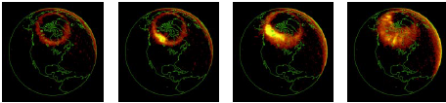

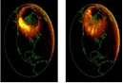

Figure ( 6) : An auroral oval seen from space as it increases in intensity and area over several hours (seen in UV light)

-Although auroras are beautiful to behold, they can be a nuisance to those who depend on modern technology.

- Before inventing the telephones, mobiles and radios , people were not affected by the influence of the aurora ,

but when the human started to use the power of electromagnetism, developing networks of electrical power and communications systems, he recognized that that the aurora could affect those systems and causes many serious problems.

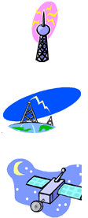-The electrons which trapped in the Earth’s magnetic field to produce the aurora makes the atoms in the atmosphere excited which mean that the atmosphere will be in unstable state ( the atmosphere will be disturbed ), and this affects [radio waves](http://www.suntrek.org/factary/r.shtml#r_radio_waves) that are communicating information around the world.

**-** Electrons which accelerated to high energies in the tail of the magnetosphere can raise damages with satellites , because The Earth's atmosphere actually expands slightly when [auroras](http://www.suntrek.org/factary/a.shtml#a_aurora) are around . This means that any low-flying satellites can hit the upper atmosphere. This can slow them down enough to make them eventually fall back down to Earth.

:

Our planet affects and get affected by the outer space in many ways causing many interesting phenomenons , thus , aurora is the proof that our planet is affected by the sun with more than sun light.

The sun spits these tiny charged particles and electrons into space , when this electrons hit the Earth’s magnetosphere and get trapped in the Earth’s magnetic field they cause this magical lights which we call the aurora.

Also auroras are very beautiful with their different colours , but they can cause many serious problems to our communication systems and electronic materials .

* Polar Mission, Mail Code 696, NASA Goddard Space Flight Center, Greenbelt, MD 20771–[*http://istp.gsfc.nasa.gov/istp/polar*](http://istp.gsfc.nasa.gov/istp/polar)
* Space Environment Center

325 Broadway, Boulder, CO 80303-3326

(303) 497-5127.

* Planet Earth Adventures , What is the Aurora Borealis or Northern Lights ? .888.513-5992 , [www.discoverak.com](http://www.discoverak.com).
* The Aurora Australis - Southern Lights,

© 1998-20142014 Polar Connections, LLC. All rights reserved. The Antarctic Connection is a registered trademark of Polar Connections, LLC.

|  |  |  |
| --- | --- | --- |
| Page |  | Subject |
| 1 | The front page | _ |
| 3 | Preface | _ |
| 4 | Introduction | _ |
| 5 | Chapter 1: | What is the aurora? |
| 6  6  7 | Chapter 2 :  Part 1 :  Part 2 : | The specification of the aurora ?  What does the aurora look like?  Does the aurora make a sound ? |
| 8 | Chapter 3 : | What causes the aurora ? |
| 10 | Chapter 4 | Why does aurora come in different colours ? |
| 12  12  12 | Chapter 5:      Part1:  Part2: | Observation of the aurora ?  Where can we see the aurora?  When can we see the aurora ? |
| 14 | Chapter 6: | How can the aurora affects us? |
| 15 | The termination | _ |
| 16 | References | _ |
| 17 | Contents : | _ |

|  |  |  |
| --- | --- | --- |
| Page | Subject | Figure |
| 5 | Corona: the corona is considered the most spectacular form of the aurora, appearing overhead with all shafts converging to a center point. | 1 |
| 7 | *A solar storm blasts out from the Sun and heads towards Earth’s protective shield, the magnetosphere* | 2 |
| 8 | The energetic electrons from the space make the atmosphere’s atoms exited. | 3 |
| 10 | The cause of the different colours of the aurora | 4 |
| 11 | UV image of auroral oval superimposed on a gure of partly sunlit Earth | 5 |
| 12 | An auroral oval seen from space as it increases in intensity and area over several hours (seen in UV light) | 6 |
|  |  |  |

1. What is the Aurora Borealis or Northern Lights , Page (1), [www.discoverak.com](http://www.discoverak.com) ,
2. Polar Mission, Mail Code 696, NASA Goddard Space Flight Center, Greenbelt, MD 20771– http://istp.gsfc.nasa.gov/istp/polar

   Courtesy: John Kappenman , page (5) .
3. Polar Mission, Mail Code 696, NASA Goddard Space Flight Center, Greenbelt, MD 20771– http://istp.gsfc.nasa.gov/istp/polar

   Courtesy: John Kappenman , page (2).
4. Space Environment Center

   325 Broadway, Boulder, CO 80303-3326

   (303) 497-5127 , page (3)
5. Polar Mission, Mail Code 696, NASA Goddard Space , Flight Center, Greenbelt, MD 20771, where can we see an aurora??, page (3).