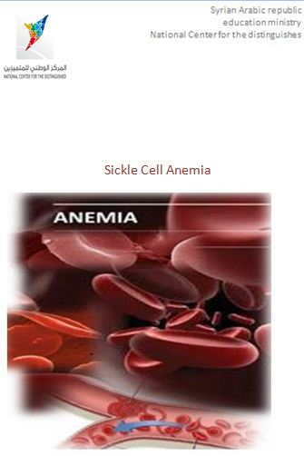

Outline

Preface

Introduction

The blood

symptoms

complications

The reasons

The diagnosis

The treatment

The Summary

The references

The catalogue

Preface

**What Is Anemia?**

Anemia (uh-NEE-me-uh) is a condition in which your blood has a lower than normal number of red blood cells.

Anemia also can occur if your red blood cells don't contain enough hemoglobin (HEE-muh-glow-bin). Hemoglobin is an iron-rich protein that gives blood its red color. This protein helps red blood cells carry oxygen from the lungs to the rest of the body.

If you have anemia, your body doesn't get enough oxygen-rich blood. As a result, you may feel tired or weak. You also may have other symptoms, such as shortness of breath, dizziness, or headaches.

Severe or long-lasting anemia can damage your heart, brain, and other organs in your body. Very severe anemia may even cause death.

Many types of anemia can be mild, short term, and easily treated. You can even prevent some types by following a healthy diet. Other types can be treated with dietary supplements.

In this research I talk about the blood to know more about its parts and about :

* Sickle cell anemia , its symptoms and complications
* Discuss the reasons
* Diagnosis this disease
* Can we treat it or avoid it at all ?

We will answer all this question in this research.

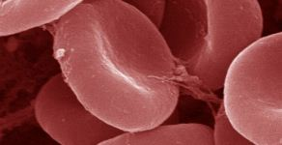

Picture(1 )

Introduction

Sickle-cell Anemia(SCA) is a sickness that occurs when the body produces a red globule not in good appearance .the globules look like crescent or sickle. And this is why it took its name.

The sickle globules don't live as long as healthy red globules do ,this sickle ones stick in blood lodes and stop blood's flow ,that causes pains and, as a result, the organ is destroyed ,the matter which cause a lot of health problems in the body .

In this research, we will talk about sickle-cell anemia ,explain about its indication and reasons , and give diagnosis and medication for it.

This sickness is a big problem by itself, but it's multiplications make it into a disaster so can we solve this problem? , reduce the multiplications?' or avoid it at all?

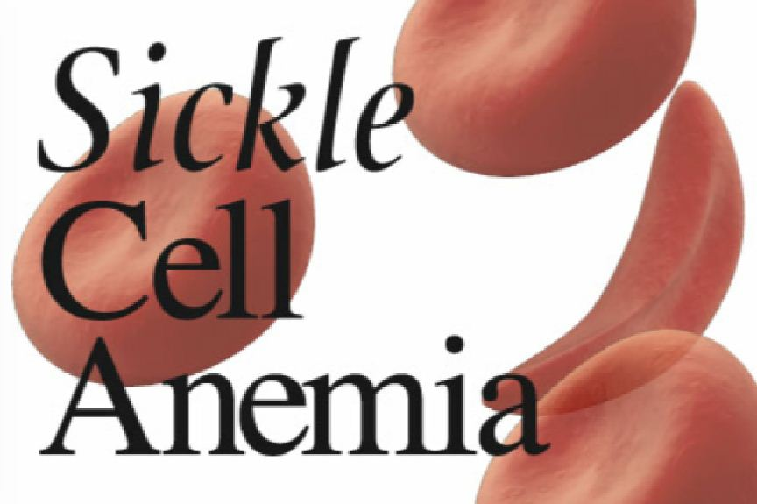

Picture(2 )

**Section** one The blood

"Sickle cell anemia is an illnesses in the blood . the blood moves everywhere in the body ,and it helps transporting the foodstuffs and oxygen to the body's cells.

And the blood carries the picking to the liver and reins , both members can filtrate the blood because they can exclude the unhealthy materials .

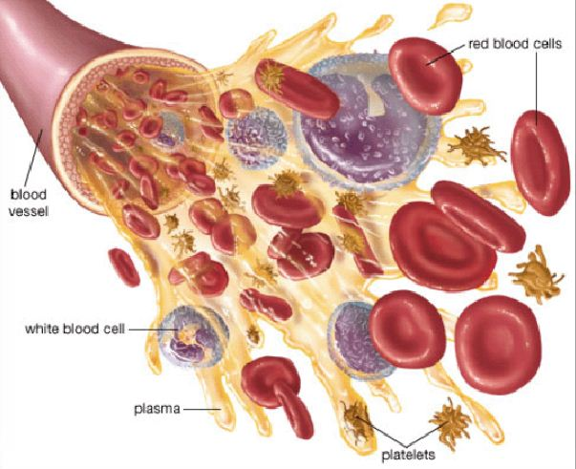

picture (3)

Blood is made up of many parts: red blood cells, white blood cells, platelets (PLATE-lets), and plasma (the fluid portion of blood).

Red blood cells are disc-shaped and look like doughnuts without holes in the center. They carry oxygen and remove carbon dioxide (a waste product) from your body. These cells are made in the bone marrow—a sponge-like tissue inside the bones.

White blood cells and platelets (PLATE-lets) also are made in the bone marrow. White blood cells help fight infection. Platelets stick together to seal small cuts or breaks on the blood vessel walls and stop bleeding. With some types of anemia, you may have low numbers of all three types of blood cells."[1]

**Section tow The symptoms :**

What Health Problems Does Sickle Cell Disease Cause?

"_“Pain Episode” or “Crisis”:Sickle cells don’t move easily through small blood vessels and can get stuck and clog the blood flow. This causes pain that can start suddenly, be mild to severe, and last for any length of time

.

_Infection:People with SCD, especially infants and children, are more likely to experience harmful infections such as flu, meningitis, and hepatitis.

_Hand-Foot Syndrome**:** Swelling in the hands and feet, often along with a fever, is caused by the sickle cells getting stuck in the blood vessels and blocking the blood from flowing freely through the hands and feet.

_Eye Disease:SCD can affect the blood vessels in the eye and lead to long term damage.

_Acute Chest Syndrome (ACS):Blockage of the flow of blood to the lungs can cause acute chest syndrome. ACS is similar to pneumonia; symptoms include chest pain, coughing, difficulty breathing, and fever. It can be life threatening and should be treated in a hospital.

_ Stroke:Sickle cells can clog blood flow to the brain and cause a stroke. A stroke can result in lifelong disabilities and learning problems."[2]

**Section three the complications**

"The cells sickle turns can catch many parts of body, and causes health problems ,that’s what we call the complications. It take place because of cells sickle turns ,and it contains the complications which is related with sickle cells anemia such as:

* hand and foot correlative.

* spleens turns.

* hard correlative chest

* pulmonary hypertension.

* beaded growing and adulthood.

* apoplexy.

* eyes trouble.

* organ's fail.

The sickle cells can close the blood vessel in the hands and foots at the children who are under the age of four, this, however, calls hand and foot correlative, it cause pains, tumefaction and fever. It could happen to one hand or both or the foots at the same times.

*Spleen turn is another problem, which happens when this organ hooks up the red blood cells and cause the spleen hugeness that leads up to the anemia. The patient need blood until the body can produce more , the children and infant can catch this disease and cause the death, we should keep an eye on the symptoms like high fever , and it is important to take fast treatment measures for :_cough. _breathing problems.

_bones pains .

_headache.

hard correlative chest is health life threatening problem ,it is related to the sickle cells anemia. it cause s chest pain, dyspnea and fever .It happens because of small blood vessel damaging in the lungs that hinders the heart from pumping the blood across the lungs the matter which causes pulmonary hypertension ,and this leads to dyspnea and exhaustion .

children with sickle cells anemia are slow in growing than the other, and beaded adulthood because of red cells weakness , the adults with sickle cells anemia are slimmer and smaller than the others .

if a blood vessel is closed or damaged in the brain ,it will cause apoplexy which causes learning's problems or brain's damage. If the sickle cells close the small blood vessels in eyes ,it will cause blindness ,and if it happens in the arms or legs ,it will cause the hand and foot correlative. In the end ,we know that the red sickle cells cause the organs's fail.

The symptoms of the organs' fail are:

Fever.

Fast palpitated.

Breathing troubles.

Changes in the brain situation."[3]

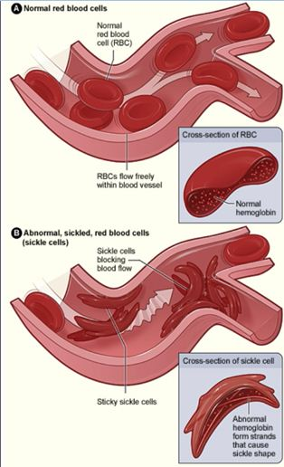

Picture (4)

**section four The causes of sickle cell anemia**

it is a genetical disease

How Does Someone Get Sickle Cell Trait ?

People who have inherited one sickle cell gene and one normal gene have SCT,i.e, the person won’t have the disease, but will be a trait “carrier” and can pass it on to his or her children.

What Are The Chances That A Baby Will Have Sickle Cell Trait?



Picture (5)

" If both parents have SCT, there is a 50% (or 1 in 2) chance ••that the child also will have SCT if the child inherits the sickle cell gene from one of the parents. Such children will not have symptoms of SCD, but they can pass SCT on to their children.

If both parents have SCT, there is a 25% (or 1 in 4) chance that the child will have SCD.

There is the same 25% (or 1 in 4) chance that the child will not have SCD or SCT.

If one parent has SCT, there is a 50% (or 1 in 2) chance that the child will have SCT and an equal 50% chance that the child will not have SCT."[4]

**section five The diagnosis**

**"How Will A Person Know If He Or She Has Sickle Cell Trait?**

Diagnosis of sickle-cell disease is based on testing the haemoglobin. Typically, this testing involves protein electrophoresis or chromatography, which are cheap

techniques and widely available worldwide, although haemoglobin mass spectrometry and DNA testings are being increasingly used because these techniques enable high-throughput testing. Antenatal screening is

available to women in some countries to help identify couples who are at risk of having a baby with sickle-cell disease, and to offer prenatal diagnosis. Universal

neonatal screening programmes are established in the USA and England, with other programmes being developed in Europe and Africa. Some of the

improvement in survival in sickle-cell disease over the past few decades has been attributed to neonatal screening, facilitating early access to prophylaxis with

penicillin, comprehensive care, and parental education on the early detection of complications such as acute splenic sequestration (panel 1).

A simple blood test can be done to find out if someone has SCT.

Testing is available at most hospitals or medical centers, from SCD community-based organizations, or at local health departments.

A small sample of blood is taken from the finger (a “needle prick”) and evaluated in a laboratory.

If the results of the test reveal that someone has SCT, it is important that he or she know what SCT is, how it can affect him or her, if and how SCD runs in his or her family.

The best way to find out if and how SCD runs in a person’s family is for the person to see a genetic counselor. These professionals have experience with genetic blood disorders. The genetic counselor will look at the person’s family history and discuss with him or her what is known about SCD in the person’s family. It is best for a person with SCD to learn all he or she can about this disease before deciding to have children."[5]

**Section six Common Treatment Options for Sickle Cell Disease**

What are some treatment options for sickle cell disease?

**"Hydroxyurea**

Hydroxyurea is a medicine that can help children and adults with sickle cell disease.

Research studies show that hydroxyurea lowers the following:

• The number of acute chest syndrome (Pneumonia) events

• The number of pain crises

• The need for blood transfusions

• The number of trips to the hospital

Hydroxyurea is given by mouth one (1) time each day. It comes in liquid or capsule form.

**Red Blood Cell Transfusions**

Red blood cell transfusion involves the transfer of red blood cells from one (1) person

to another. Red blood cells are obtained when a person donates blood. Transfusions

are done for different health problems caused by sickle cell disease. Sometimes only a single transfusion is needed. Other times, patients need long-term transfusions, which could mean receiving blood one(1) time a month."[6]

"These are some reasons a sickle cell patient might need blood transfusions:

**_**Stroke**:** When a stroke occurs, the brain suffers damage because blood flow is blocked to a portion of the brain.

Chronic transfusions are used to prevent further strokes and brain damage, and they are usually given for the rest of a patient’s life.

**_**Acute chest syndrome (pneumonia):When anemia is at its worse, the patient will have trouble breathing and often the oxygen level in the body is lower than it should be. In such cases, a transfusion may be needed. "[7]

**Bone Marrow (Stem Cell) Transplant**

"In a person with sickle cell disease, the bone marrow produces red blood cells that contain hemoglobin S. This leads to the complications of sickle cell disease.

During a bone marrow transplant, the bone marrow of a person with sickle cell disease is replaced by blood-forming stem cells from a donor who does not have sickle cell disease. This can result in a cure for the disease.

The first bone marrow transplant on a person with sickle cell disease was performed in 1984 on a St. Jude Patient.

Two major requirements must be met for a transplant to proceed.

• Identify the person who is the best match (donor).

• After the donor is chosen, both the donor and the patient will have pre-transplant evaluations of the heart, lungs, kidneys, etc.

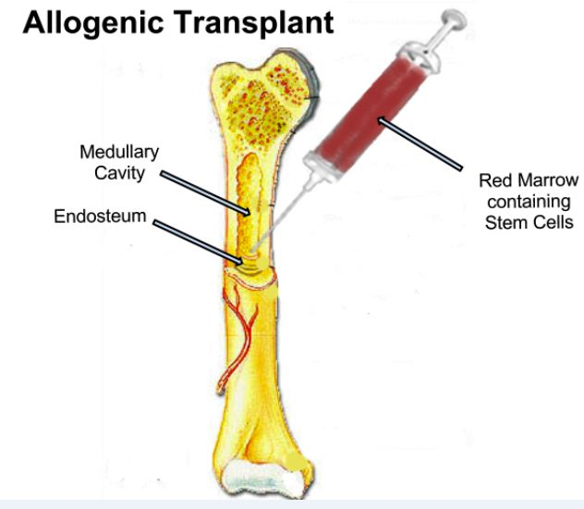These requirements limit bone marrow transplants for people with sickle cell disease because of the small chance of having a matched donor"[8] Picture (6 )

**The Summary**

**\*** There is no single best treatment for all people with SCD. Treatment options are different for each person depending on the symptom.

**\***  A nutritious diet and a good fluid intake (8–10 glasses of liquid per day) are important for maintaining good health.

A moderate exercise program, based on your own tolerance, is recommended.

Alcohol, street drugs, and tobacco can greatly increase a person’s risk of developing serious complications of sickle cell disease.

**\*** These are the three main treatment options for sickle cell disease:

• Hydroxyurea—reduces pain and acute chest syndrome.

• Red Blood Cell Transfusions—can be one time or long-term.

• Bone Marrow Transplant—A cure for sickle cell disease.

**\*** Although the Bone marrow or stem cell transplants are very good treatment, they might be very risky, and can have serious side effects, and may lead to death. For the transplant to work out, the bone marrow must be a close match.

**The references**

* Sickle cell disease published by :National Center on Birth Defects and Developmental Disabilities.
* what you should know about sickle cell disease published by : National Center on Birth Defects and Developmental Disorders.
* About Sickle cell disease published by : National Center on Birth Defects and Developmental Disorders.
* Taking control :teens with sickle cell disease published by : Department of Hematology St. Jude Children's Research Hospital 262 Danny Thomas ,Mall Stop 800 Memphis.
* Scientific Encyclopedia for Medical Content.

* A Seminar about Sickle-cell disease by David C Rees, Thomas N Williams, Mark T Gladwin published in December 11, 2010.

Picture catalogue

|  |  |  |  |
| --- | --- | --- | --- |
| Page number | The references | about | Number of the picture |
| 3 | Biology book –the ninth grade | Red cells | 1 |
| 4 | Biology book –the ninth grade | Sickle cell | 2 |
| 5 | Biology book –the ninth grade | Parts of the blood | 3 |
| 8 | Taking control: teens with sickle cell anemia | Sickle cell close the blood vessel | 4 |
| 9 | What you should know about sickle cell anemia | How can we catch sickle cell anemia | 5 |
| 12 | Stem cell transplant- center for disease control and prevention | Bone marrow transplant | 6 |

**The catalogue**

|  |  |
| --- | --- |
| The section | The pages |
| Preface | **3** |
| Introduction | **4** |
| 1-The blood | **5** |
| 2-Symptoms | **6** |
| 3-Complications | **7** |
| 4-The causes | **9** |
| 5-The diagnosis | **10** |
| 6-The treatment | **11** |
| The Summary | **13** |
| The references | **14** |
| Picture catalogue | **15** |
| The catalogue | **16** |

1. Scientific Encyclopedia for Medical Content page( 1)
2. What should know about sickle cell disease page (1)
3. Scientific Encyclopedia for Medical Content page( 2)
4. **What You Should Know About Sickle Cell Trait page (1)**
5. **What You Should Know About Sickle Cell Trait page (2)**
6. **Taking Control: Teens with Sickle Cell Disease page (28)**
7. **Taking Control: Teens with Sickle Cell Disease page**(29)
8. **Taking Control: Teens with Sickle Cell Disease page (29)**