Syrian Arab republic
Ministry of Education
National Centre For The Distinguished

English seminar.
By Raneem Shaaban Mahfoud.
To Miss Mirna Samaan.
2014-2015

Introduction:

NLP is a powerful technology and therefore it must be used responsibly and ecologically. Ecology is an important concept in NLP.
In essence it’s the study of consequences. To be truly ecological, whatever you do should not only be good for you but for others around you and indeed the planet in general. An ecology check is often the most important step that is missing in traditional goal setting. No wonder so many people achieve their goals and are still unhappy. Remember King Midas. He wanted everything he touched to turn to gold. If he’d put his goal through an ecology check he would have realized some of the consequences of that decision.
Our experience of NLP and those practicing it has been largely ecological. Just like an axe can be used to either to chop wood or to harm someone, some people use NLP in a way that is not ecological .but, the good news is you can see them coming!
Our guiding principle is that NLP is something you do with others and not to them. This is an important distinction.
We wish you great enjoyment and success on your own NLP journey!

Neuro linguistic programming definition:

It's rather unfortunate name for something so popular and powerful!, and there are many stories in the NLP folklore about how the name came out.
NLP was created by Richard Bandler & John Grinder at the university of Palo Alto in California in the early 70s. It gained recognition through the publication of their first book, "The structure of magic"; volume 1 in 1975.
One helpful way to explore a definition is to separate out its three core elements;

Neuro | This refers to our neurology and more specifically to our five senses (sight, hearing, touch, smell, taste) through which we take information from the environment around us.
Linguistic | Our language, verbal and non-verbal, and how we code, organize and give meaning to our experiences.
Programming | The strategies and approaches we use to achieve consistent results or outcomes.

Attitude | Through extreme curiosity, wanton experimentation and actin 'as if '.
Methodology | Modeling what someone with exceptional talent does and teaching it to others for accelerated learning.
Techniques | A host of tried and tested tools that enable practitioners and clients alike to achieve their outcomes, resolve problems and create generative change for individuals and organizations.
In other words, NLP is how minds use its own language to consistently achieve our specific and desired outcomes.
NLP has often been described as study of subjective experience, Richard Bandler defines it as being an attitude and methodology that leaves behind a trial of techniques.*
The strategies of success:
Although extracting a model of excellence is mostly done with specific skills is specific contexts, it is relatively easy to translate that model across contexts. Since Bandler & Grinder's early modeling some powerful patterns have emerged such as the five strategies of successful people.
- Know your outcome.
- Take massive action.
- Have exceptional sensory acuity.
- Have behavioral flexibility.
- Operate from a physiology and psychology of excellence.

NLP provides a synthesis of knowledge and aspects of it are to be found in popular self-help programs such as the law of attraction and most , if not all, motivational speakers and several prominent world leaders have been trained in NLP.

Why do you want to learn NLP?
The answer to this question is quite personal. However, when you have the answer you will be better prepared to select the right NLP training for you.
Historically, there are four main reasons why you would want to learn NLP:

- Personal development.
- Add skills to your therapeutic/ coaching career.
- Add skills to your training / teaching/ presenting career.
- Develop more effective communication, influencing and negotiation skills for business.

In practice, most people train in NLP for more than one of these reasons. When you have identified your own reasons then you'll know what level of NLP training you want to do.

What is NLP?
We already defined NLP in the introduction and now you're probably wondering what NLP is specifically. In this section, we will present some core NLP concepts and describe what you can expect to learn up to Practitioner and Master Practitioner level.

NLP Presuppositions
We will start with the NLP Presuppositions. These are a series of empowering beliefs that we act "As if" they are true generate consistent results in everything we do. The list varies according to where you source them and you'll find that the most common ones are:
- You cannot not communicate.
- People respond to their experience not to reality itself.
- Having a choice is better than not having a choice.
- Everyone has a unique model of the world.
- Respect other peoples' models of the world.
- The map is not the territory.
- People are not their behavior.
- All meaning is context dependent.
- Every behavior has a positive intention.
- The most important information about person is how that person is behaving.
- Everyone is doing the best they can with the resources they have available.
- There are no un resourceful people, only un resourceful states.
- Everyone has all the resources they need to succeed and to achieve their desired outcomes.
- The person with the most flexibility of behavior has the greatest influence on others.
- There is no failure, only feedback.
- Everyone in in charge of their mind, and therefore their results.
- The meaning of communication is the response you get.
- Resistance in a client or audience is a sign of a lack of rapport.

In two minds:
There are two primary ways in which we make sense of the world:
Consciously and Unconsciously.
Your consciously mind is the mind that is actively thinking for you all day long. It often manifests itself as that inner voice that talks to you, the one you think of as "me".
Whilst the conscious mind certainly has its uses; it is limited in what it can achieve on its own. Research has shown that it can only focus on 5 to 9 things at one time. Therefore, it needs support.

Your unconscious mind provides that support. It is your larger mind and can process millions of messages of sensory information per second. It contains all of your wisdom, memories and intelligence.It Is the source of your creativity. It stores all the “programs” of automatic behavior you use to live your life.
In other words, it looks after you and keeps you safe.

The unconscious mind is like having an autopilot function in the brain. It enables you to carry out multiple functions without having to concentrate on all of them at once.

These programs are useful because they free your conscious mind
up to concentrate on other things.
Sometimes, like on your computer, you need to change, override,
rewrite, upgrade or completely delete these programs.
The NLP communication model:

Neuro-Linguistic Programming (NLP) is about noticing patterns. So, in NLP, we are not so much interested in content as in process, structure and form. Often this is an interesting transition for us to make. The first step is to pay attention to the process of your interaction with others - listen to the form, watch the form, feel the form, and not get involved in the content.
Communication Model 1
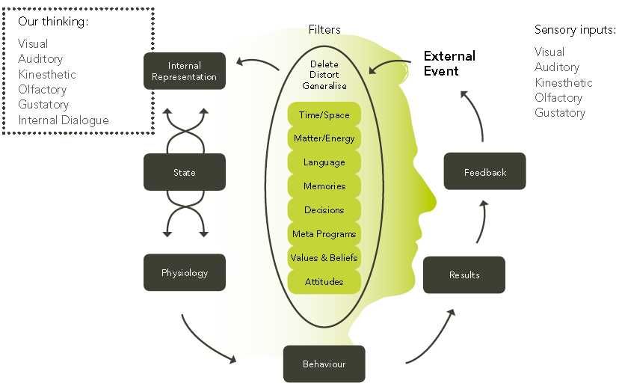 The NLP This Communication Model enables us to understand how we make sense of the world around us, how we communicate, learn, behave and change. It’s only a model and as with all models it is more or less useful in different contexts. The belief is that "The map is not the territory". And so the internal representations that we make about an outside event are not necessarily the event itself.
As a human being and someone able of conscious (and unconscious) thought you may currently believe that the world that you perceive is real. And it is. To you. The world you perceive is real only to you because it is different from the world, which others perceive. Many things including what you believe; your experiences; your memories and many other mental ‘filters’ affect your perception. These influence and colour the representation of the world inside your mind that you then act upon.

Information about external events comes in through our sensory input channels and it is filtered to what is important to us. Although there are many specific filters there are three major unconscious filters, which are absolutely necessary to understand and cope with the world around us.

And the main three unconscious filters are:

• Deletion

We delete a lot of information at any one time. Right now, become aware of your left big toe. Now, where was it until I mentioned it? That’s deletion. We miss things all the time overlook the obvious and tune out. You will have deleted much of the information that has been provided to you already today.
For example:
- What color is the car parked next to yours in the car park?
- How much money do you have in your pockets?
- What was the very first thing someone said to you this morning?

•Distortion

We bend reality to fit - we read between the line and hear what we think we hear, or make it the way we want it. Daydreaming is distortion, seeing faces in clouds. That’s distortion at work. Twisting our perception to make the outside world agree with our internal opinion.
•Generalization
We group things together and say, “This is like that”. Cushions, stools and sofas are all places to sit, so if you came into my house and I said “Please sit down” you’d know what to do. You compare new data to what you already know, which is the basis of all learning. Every morning when you swing your legs out of bed they always go down to the floor. They never go up. You’ve learned that now.

So, what’s left after we delete, distort and generalize?

Internal Representation:

Our Internal Representation is made up of pictures, sounds, feelings, smells, tastes and our self-talk – these are the six modalities, which form our version of reality. One of the most important discoveries in NLP was that of Sub Modalities. These are the finer distinctions that we make within our modalities and are the bits that code and give meaning to our experiences. So, it was discovered that the intensity of meaning that someone gave to an experience was directly related to the sub-modalities they used within their representational system.
For example, to know that someone visualizes is not enough. We need to know how they visualize. Is the image they make black and white or color, is it moving or still, is it big or small, framed or panoramic, near or far, focused or blurred, etc… The same goes for sounds and feelings. Often, one of these sub-modalities is critical to the meaning the person is giving an experience or memory. By identifying this sub-modality driver it is possible for someone to reframe and change their experience of an event.
If you listen really carefully to the specifics of the language that someone is using they often reveal the sub modalities of how they store their experiences, problems etc. When someone talks about “needing to get things in perspective” or “wanting some distance” from a problem they are telling you through their sub modalities what is really influencing them.

Whether working with colleagues, direct reports or coaching clients by using this information you can enable them to radically change their experience of an event, solve problems quickly and move on. But before we can do anything with NLP we need to connect. How do we do that?

Rapport:
The basis of rapport is that when people are like each other, they like each other. When people are not like each other, they don't like each other. When you like someone, you are willing to assist them achieving what they want. Research has shown that 38% of all communication is tone of voice, and 55% is physiology. So, most communication is outside of our conscious awareness. A tremendous opportunity exists for communication outside of normal channels, and that's what rapport is all about.

Sensory acuity:
One of the delicate secrets of NLP is the development of Sensory Acuity. Richard Bandler & John Grinder both refer to the importance of it from the earliest NLP texts such as ‘Frogs Into Princes’ right through to the modern trainings of today. Perfecting your Sensory Acuity is one of the keys to true mastery in communication. It is essential in getting in rapport with another person.

Elements of rapport:
Too often communication takes place in system where people unconsciously mismatch modalities. So the first element of rapport is to match the modality the person is using. On the next page are lists of predicates, and predicate phrases. These predicates are sorted into 4 main categories:
- Visual.
- Auditory.
- Kinesthetic (which includes Olfactory and Gustatory).
- Auditory Digital (our self-talk).

Look at these now, and notice the words and phrases that people use in each major representational system. In each major representational system, people are using different words, different phrases that actually reveal what's going on inside their heads.

Auditory Digital
Sense
experience
understand
think
learn
process
decide
motivate
consider
change
perceive
insensitive
distinct
conceive
know

Visual

See
look
appear
view
show
dawn
reveal
envision
illuminate
twinkle
clear
foggy
focused
hazy
crystal clear
Kinesthetic
Feel
touch
grasp
get hold of
slip through
catch on
tap into
make contact
throw out
turn around
hard
unfeeling
concrete
scrape
get a handle on
Auditory
hear
listen
sound(s)
make music
harmonize
tune in/out
be all ears
rings a bell
silence
be heard
resonate
deaf
mellifluous
dissonance
overtones

The second element of rapport is physical mirroring of the individual's physiology. Actually physically copying their posture, facial expressions, hand gestures and movements, and their eye blinking will cause their body to say unconsciously to their mind, "Hey, he's like me!" It's undeniable to the nervous system.

The third element is to match their voice: The tone, tempo, timbre (quality of the voice), and the volume. You can also match their key words. Perhaps they often say, "Actually." You can use it in a sentence several times. Say it back to them.

The fourth element is to match their breathing. You can actually pace someone's breathing by breathing at exactly the same time as they do (matching the in and out breath). By matching their breathing, by pacing their breathing, you can then begin to lead them out of the representational system they're in, into another one.

The fifth element is to match the size of the pieces of information (chunk size or level of abstraction) they deal with. If someone usually deals in the big picture, they will probably be bored with the details. On the other hand someone who is into details will find that there's not enough information to deal with, if you only give them the big picture. So make sure that you are matching the content chunks that the person deals with.

The sixth element is to match their common experiences. This is what's usually called rapport. When people first meet, often their early relationship is about matching common experiences, common interests, background, beliefs and values, their ideologies and common associations.
-These are the critical elements of rapport. So now you know how to establish and maintain rapport even when you disagree with someone.
Getting what you want:
Why are goals and outcomes important?
Alice: Would you tell me, please, which way I ought to go from here?
The Cat: That depends a good deal on where you want to get to
Alice: I don't much care where.
The Cat: Then it doesn't much matter which way you go.
Alice: …so long as I get somewhere.
The Cat: Oh, you're sure to do that, if only you walk long enough.
~ Alice in Wonderland, Lewis Carroll

-Being clear about what you want to achieve is a key aspect of NLP
and in order to do this there are some distinctions that we make.
Focus on what you want:
Our minds cannot process a negative statement directly because we cannot put our attention on something without it becoming part of our experience. When I give you the instruction: “Don’t think of a pink elephant!” the first thing you do is think of a pink elephant. Another way of putting it is you cannot think about what you don’t want to think about without thinking about it! This has enormous consequences for what we achieve in life. We always experience what we focus on. When you focus on what you don’t want you tend to get more of it. Strange, isn’t it!?

Beware of static Positive Affirmations!
For many years people have been evoking positive states and changing their values in life. This is a powerful and excellent thing. However, it’s important to explain that stating affirmations, such as ”I am an excellent individual who deserves to be loved”, often fails to address the limiting beliefs, negative emotions and ineffective strategies that may have brought you to the point where you required affirmations in the first place!
A better affirmation is: “Every day, in every way, I’m getting better and better” ~ Emile Couet. This is effective because it works with the person’s current experience. A static affirmation risks mismatching a person’s current experience and therefore the results are unpredictable.
NLP tools such as Belief Change, Re imprinting and TimeLine Therapy enable you to clear the underlying issue and achieve goals that ensure positive change lasts forever.

The NLP Models:

The Meta Model
This model was the first NLP model and was based on the modeling of therapists Virginia Satir and Fritz Perls. Bandler and Grinder combined this modeling with Grinder’s expertise in Transformational Grammar and published the results in the book The Structure of Magic Volume 1 (1975). As we’ve seen we communicate in words by deleting, distorting and generalizing the deep structure of our experience into a spoken surface structure. The Meta Model is a set of language patterns and questions that reconnect the deletions, distortions and generalizations with the experience that generated them. These language patterns and questions ‘reverse engineer’ the language working on the surface structure to uncover the deep structure behind it.
So, essentially the Meta Model uncovers lots of missing information or details and can be applied in any situation where we need to get more specific e.g. in an interview, meeting or a coaching session.
The Milton Model
The Milton Model was the 2nd NLP model to be published. Bandler and Grinder modeled the exceptional therapist Milton Erickson, who gave his name to a leading branch of hypnotherapy: Ericksonian Hypnosis. In some ways the Milton model is the mirror image of the Meta Model. Whilst the Meta Model drills down the Milton Model deliberately generates vague surface structures that give the listener the greatest amounts of choice in choosing a deep structure and sensory experience to match the words. In this way, Milton Model patterns pace the listener’s reality and they are vague enough to mean whatever you want them to mean. This means that your listener has the opportunity to access their full unconscious resources, which in turn enables them to solve difficult problems and make changes relatively easily.
In practical situations, Milton patterns are very useful. For example, in getting instant rapport with someone and in negotiations - chunking up enables people to find points of agreement. This table shows how the two models complement each other:
Meta Model | Milton Model
Chunks language down, makes it more specific | Chunks language up, makes it more general
Moves from deep structure to surface structure by challenging deletions, distortions and generalizations. | Moves from surface structure to deep structure by generating deletions, distortions and generalizations.
Concerned with bringing experience and meaning into consciousness. | Concerned with unconscious resources.
Deals with the results of a trans derivational search. | Provokes a trans derivational search.
Deals with precise means. | Deals with general understandings.
Accesses conscious understanding. | Accesses unconscious resources.

The Hierarchy of Ideas:
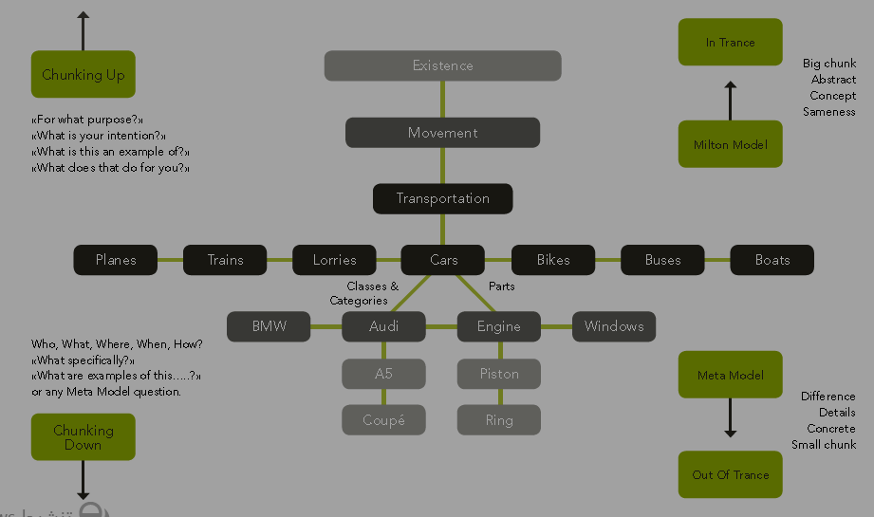
The Hierarchy of Ideas is a model of the scope of our thinking and juxtaposes the Meta Model and the Milton Model. It also demonstrates our potential for lateral thinking through the use of Metaphor.

The Hierarchy of Ideas model 1
There are several ways of chunking down and inevitably you’ll end up making a choice between chunking down on parts or chunking down on categories. At its extreme it’s the structure of nit picking and mismatching. We use the Meta Model to chunk down.
Chunking up moves us in the direction of abstraction and the language becomes highly nominalized. Nominalizations are process words or verbs that have become suspended in time e.g. transportation, communication and leadership. A nominalization is any noun that you cannot put in wheelbarrow because of its abstraction. At its extreme it’s the structure of overwhelm because the chunks are too big. We use the Milton Model to chunk up.
When we chunk sideways we are essentially using Metaphor. Being able to use metaphor is a basis of good communication, writing, training, teaching and therapy. In NLP metaphor covers figures of speech, stories, comparisons, similes and parables.
Metaphors compare one thing with another in order to illuminate. Paradoxically, by making a comparison they make the original meaning clearer. We need comparison to understand. Metaphors are all around us, particularly in stories. In ancient societies stories are how wisdom, science, law, political and economic ideas were passed on. In organizations they are the windows to an organization’s culture.

Open to interpretation
Why bother with the Hierarchy of Ideas in the first place? Quite simple. Often when we communicate some of us communicate very specifically and others communicate quite vaguely. This can lead to lots of tension, misunderstanding and conflict, especially at work.
We may think we’re communicating when we say something like “we’ve got to improve our communication” and the other person(s) probably thinks that he knows what you’re talking about. However, their interpretation of communication (a vague term) may be entirely different from yours.
So, when they improve their communication you may get a shock! No wonder so many people get stressed out because they’re not quite sure what their boss wanted when he said we have a communication problem in this organization and you need to do something about it.
Needless to say, some professions such as politics enjoy using vague language for obvious reasons!

Framing:
Nothing has meaning in and of itself. Information does not exist on its own. It must be understood in context. The meaning we derive from any experience depends on the context or frame we apply. This is similar to how we frame or crop pictures or zooming in and out of a scene in a movie. So the frame we use sets the focus of our attention and colours and shapes our experience.
“There is nothing either good or bad but thinking makes it so”
~Shakespeare.
The frame you set governs the questions you ask about what happens, how you feel about it, how you react to it and how you deal with it. A powerful way of setting frames is through questions because they include assumptions about an event.

There are seven important frames used in NLP:
- The ecology frame: looks to the long term and you evaluate how an experience fits into the wider system of family, friends and the universe. The opposite is the ‘me’ frame, which says ‘if it’s ok for me now, then it’s OK’.
- The outcome frame: The Outcome frame: evaluates events by whether they bring you closer to your outcomes and it should be used in conjunction with the Ecology frame. The opposite of this frame is the ‘blame’ frame. ‘What’s wrong and who’s to blame?’
- The Back track frame: restates key points using the other person’s own words, often matching voice tone and body language as well. It ensures rapport. The opposite is the ‘paraphrase’ frame, which says ‘I define what you said and what you meant’.
- The Contrast frame: evaluates by difference. Not just any difference but the ‘difference that makes the difference.’ The opposite is the ‘sameness’ frame, which says ‘it’s all the same really, it doesn’t matter’.
- The ‘As If’ frame: evaluates by pretending something is true in order to explore possibilities and is very useful for creative problem solving and accessing your intuition. The opposite is the ‘helpless’ frame, which says ‘if I don’t know, then there’s nothing I can do about it’.
- The Systemic frame: evaluates by relationship. You do not focus on a single event but on how it relates to other events as part of a system. Essentially, we’re looking at patterns. The opposite is the ‘laundry list’ frame, which says ‘make a list of every possible relevant factor and then we will understand it’.
- The Negotiation frame: evaluates by agreement. It assumes that everyone would like to come to an accord. The opposite is the ‘war’ frame, which says ‘I want something and I’m going to get it even if it kills us both’.
We also have five frames, adaptations of the above and which we use for problem solving:
  - Outcomes rather than Blame / Results versus Reasons.
  - ‘How rather than ‘Why’.
  - Possibilities rather than Necessities.
  - Feedback rather than Failure.
  - Curiosity rather than Assumption.

Exploring relationships:
Two important NLP tools are worth referring to here briefly, the Meta Mirror (also known as Perceptual Positions) and Neurological Levels of Change. Both were developed by Robert Dilts, who was in the original group of students at Palo Alto that assisted Bandler and Grinder with their research.
The Meta Mirror
The Meta Mirror is a process to explore a relationship with another person. It essentially enables you to explore the relationship from 3-4 different perspectives or perceptual positions:

First position is your own reality, your own view of any situation. Personal mastery comes from a strong first position. You need to know yourself and your values to be an effective role model and influence others by example.

Second position is making a creative leap of your imagination to understand the world from another’s perspective, to think in the way they think. Second position is the basis of empathy and rapport. It gives us the ability to appreciate other people’s feelings. You can have 2 types of 2nd position: emotional, which is understanding another person’s feelings and intellectual, which is understanding how another person thinks.

Third position is stepping outside your view and the other person’s view to a detached perspective. There you can see the relationships between two viewpoints. Third position is important to check the ecology of your outcomes. It enables you to see the consequences.
Fourth position gives you a true Meta view and answers the question: how does this relationship fit into the bigger picture or system. It is very useful when working within organizations.

Conclusion:
If you always do what you've always done; you will always get what you've always got… and there's always more!
And It's good to know that the daily routines and behaviors of each one of us is clear signs of personality's patterns and a key to the way we can deal with each other.
We hope that you enjoyed and understood this research; and use it in your daily life as an important tool to communicate.

References
- Intro to NLP With Master Trainer Michael Stevenson MNLP, MTT, MHt.
- NLP learning styles accelerated learning; Phil Chambers.
- NLP Chicago bta; Mark Walton.
- Sprouts Change Management Pvt.
- www.nlpforchange.com /30 – 12 – 2014 14:50
- http://www.prioritysky.com / 30 – 12 – 2014 15:00
- www.gerrymurray.com / 30 – 12 – 2014 16:25.

Subject | Page
Introduction | 1
The definition | 2
The strategies of success | 3
NLP presuppositions | 4
The communication model | 7
The unconscious filters | 8
Internal representation | 9
The rapport and its elements | 11
The NLP models | 15
The Hierarchy of ideas | 17
Framing | 19
The relationships | 22
The conclusion | 23
References | 24

Intro to NLP With Master Trainer Michael Stevenson MNLP, MTT, MHt. Page 10.
13Intro to NLP With Master Trainer Michael Stevenson MNLP, MTT, MHt. Page
15 Intro to NLP With Master Trainer Michael Stevenson MNLP, MTT, MHt. Page
NLP learning styles accelerated learning; Phil Chambers .Page 35
NLP learning styles accelerated learning; Phil Chambers.Page37
25Intro to NLP With Master Trainer Michael Stevenson MNLP, MTT, MHt. Page

