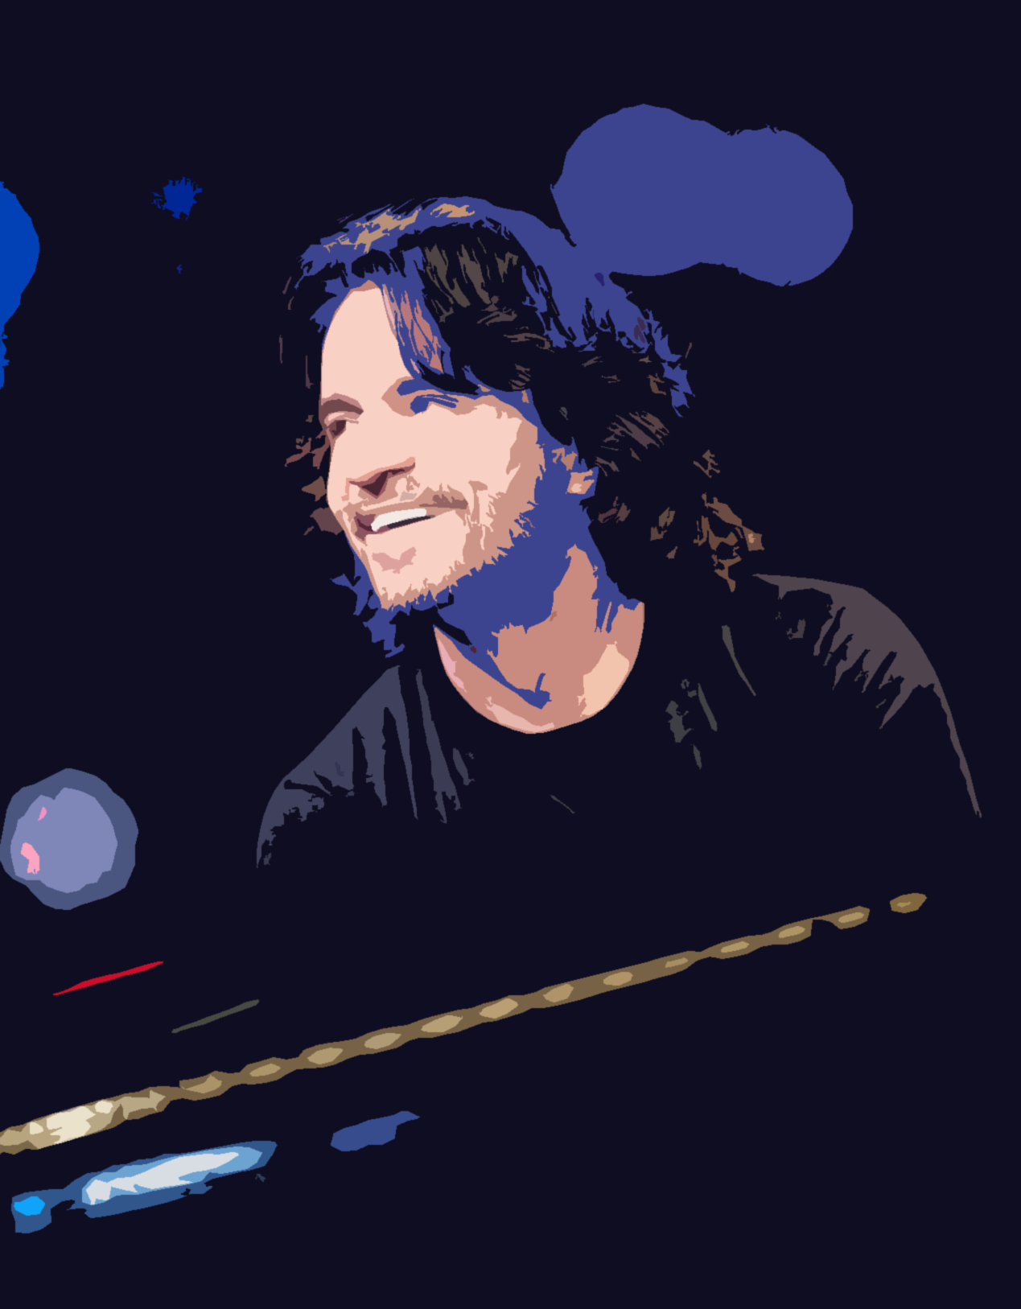
Preparation of: Maram Ahmad
Teacher: Bayan Al-sufi
Year: 2014/2015.
Yanni … special story with music
The Syrian Arab republic
Ministry of education
National Centre for distinguished
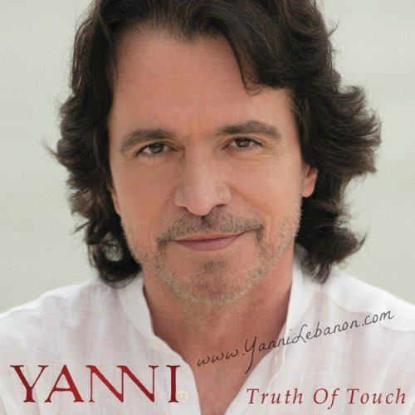
Intruduction …………………..………
It’s the music, the magic that can describe our senses, feelings, our sadness, happiness and even our wishes to the whole world.
A lot of special, skillful musicians distinguished in playing music, writing notes and symphonies ……like Mozart, Beethoven, and Bach ….
They were very talented and attracted people to listen to what they did.
But there‘s one of them who really do loves the music and tunes.
He is yanni, the talented Greek musician, many people think they have never heard Yanni’s music, since 1990s, the keyboardist work was heard by more people than perhaps that of any other composer:
From commercials to sound tracks and the sporting events .his music was and still forms a part of almost every television program.
But what about his life??Why he was affected in the music field??What’s the thing he did that specialized him relative to the other musicians??
Let us know more about him in our research.

Contents ………………….
Chapter | page | Principle titles
Introduction | 1
Yanni’s life | 3  3 | 1-Yanni childhood  2- yanni ’s studying  3- started working at the music side  4- yanni’s albums  5-yanni’s other activities
Yanni in words | 7
Yanni band | 8
Conclusion | 14
References | 15

Chapter 1: Yanni’s life ………………………………
In Kalamata, on the shores of the Mediterranean, yanni was born in November/ 1954 to Sortiri and Felitsa Chryssomallis.
The second one of three children, yanni has an older brother and a younger sister, sharing a deep-rooted love of music, the family spent a lot of time playing and singing together,
And like the other Greek sons: yanni grew up fishing, swimming and going to school. He was a very talented boy:
In 1969 at the age of 14, yanni broke the national swimming record for the men’s 50 meter free style event.
But in the other hand : yanni loved the music since he was a child ,liked to compose the special music that he heard in his head and wanted to hear it come out of the piano buttons too ,and because of that he needed to learn playing piano to make that happens . But as we know every special person needs a special ways to learn: yanni didn’t prefer the traditional method in teaching music, he felt a certain freedom with the keys that might have been crushed under the weight of structure learning instead, he played for hours trying to re-create the music he had heard on the radio or at the movies at age six, he chose to travel a different path: one which led him to share his musical gift with the people around the world.
1-2 Yanni studying
BY the time he was 16, yanni read all the works of Sigmund Freud, he decided to study psychology -in this time he didn’t have any plan to become a new music star, although music had always been a passion- for that: In 1972, with the encouragement of his parents, Yanni left his homeland to attend the University of Minnesota (the united states).
There he learnt English and at the same time, he played in local rock and roll bands and began to develop his personal musical style using both piano and electronic keyboards to create new sounds.
And like an answer about what he had by studying, yanni said in an interview with him in Dubai after his party in 2013:
“The fact that I studied psychology has affected me as a human being and if you affect me, you affect the music I write. My travels around the world have affected my singing. I wanted to learn, I wanted to feel the different places, I wanted to understand different cultures. I’d heard a lot about Dubai and it looked amazing. I saw the videos but you have to get there and feel it. You have to walk on the street, you’ve got to see the people and the look in their eyes, feel their reactions — all of that. And it’s different in each place whether it is Oman, Qatar and now we are going to Bahrain for the first time. I’m beginning to understand the soul of the people”.
1-3 when he started working at the music field
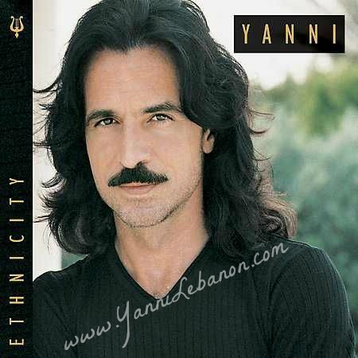
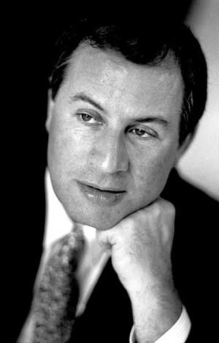
After leaving school, Yanni worked as a studio musician with the cult rock band Chameleon, and often spent fifteen-hour days at the keyboard. The distinctive musical style that developed from his hard work and talent urged him toward a solo career. In 1986 Yanni's demo tape caught the ear of Private Music's Peter Bowman; he was convinced that the musician had something special. Later that year, Private Music released Yanni's first solo album, Optimystique. From there Yanni went on to develop a tremendous following.
James Thomas Bowman CBE (born 6 November 1941) is a countertenor born in Oxford, England. His career spans opera, oratorio, contemporary music and solo recitals. In 2010 it was announced that he would give his last London concert in 2011 at the Wigmore Hall, although he would continue to give recitals outside the capital. A few years previously he retired from the Chapel Royal, St James's Palace in London, after a decade of service.
1-4 Yanni albums
Yanni is a very special sensitive musician, he has his own aim and way of thinking about his compositions .he doesn’t worry about the type of music that he does if its classic, romantic or whatever it is, he just cares about one thing: how to explain his feeling to the world.
In an interview with him, yanni said: “I do not like typos, including music. I’d say I write music and I have tremendous amount of influences from all over the world. It just comes out like that. My heart feels that. I don’t say I’m going to take some classical music, mix with some Greek music, some rock and roll and make a song. It’s just an emotion that excites me I want to describe.”
That mean: he feels, plays, transfers his message to the whole world and everyone will understand it and whatever his nationality is.
Also yanni creates his music and gives the listener a chance to make his own feeling about it, you can cry and also you can smile, it follows your own vision.
Yanni said marking to this idea: "It is my intention to share my emotions with the listener, but I also want to allow the listener to take this music and make it their own," he stated in a 1993 Private Music press release. "The only way people can fully relate to it and enjoy it is when it means something in their life.... Instrumental music, used correctly, is very direct and extremely accurate in describing even the most subtle human emotions. My music does not describe the circumstances, but how the circumstances make you feel. Since the music projects no gender, and there are no lyrics to be interpreted, the listener can personalize it, and in a far more precise way."

Yanni has a lot of albums that we can name some of them in the schedule:
Name of the album | Year
Optimystique | 1986
Keys to Imagination | 1986
Out of Silence | 1987
Chameleon Days | 1988
Niki Nana | 1989
Reflections of Passion | 1990
In Celebration of Life | 1991
Dare to Dream | 1992
In My Time | 1993
Live at the Acropolis | 1994
Tribute | 1999
If I Could Tell You | 2001
Ethnicity | 2003

1-5 Yanni’s other activities.
As we said last time that we listen yanni music and touch his impression everywhere.
In addition to his albums. Yanni has his own allocation in the television programs: “In the old days," he told Doerschuk, "I was so interested in soundtracks , when I saw a movie, I loved that had music I didn't love so much, I would take a copy of the film home, recut it, and write a new soundtrack for it. I've done 50 or 60 films that way. Now, finally, I managed to do this for real." Yanni has created music for numerous television movies, though his most widely heard television work has probably been in the area of sports. His music has been used on The Wide World of Sports and on broadcasts of the Tour de France, the World Figure Skating Championships, the U.S. Open Tennis Championships, the World Series, and the Olympic Games. In 1992, Yanni even composed the theme for the ABC-TV nightly news program World News Now. Beyond the small screen, his compositions have appeared in the theatrical release Heart of Midnight, and he has collaborated with British entertainment impresario Malcolm McLaren on an award-winning commercial for British Airways, as well as scoring music for a U.S. government film biography of Pope John Paul II.
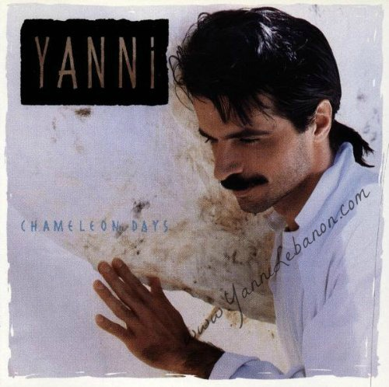
chapter 2:Yanni in words …………………………….
Yanni studied psychology and that really affected him in many sides, we can notice that by looking in his book ‘yanni in words’.
Yanni said that he never thought he will write a book but he did, he wrote “yanni in words” that talks about his life.
Let us see some of what he said in it and analyse his special personality.
Yanni is a person who believe a lot in his way of thinking, he don’t care about what people talk if he does this or that.
He said: “My father once said, 'If the whole world wants to go left and you feel like going right, go right. You don't have to follow. You don't have to make a big deal about which way you're going. Just go. It's very easy'."
"I think we have much more to say about what happens to us than most people believe."
Also we feel the ambition in his writing, and what proves that is his various musical achievements and his parties in many countries around the world: and such examples of what he said:
“It's a cliché - but true - that life is not a dress rehearsal. You get to do it once, so do it well"
“It seems that in every culture, however tough life is and however impossible the conditions, there are some resilient human beings who find their way through, who survive and make something of themselves”
“I don't want problems solved for me. I want the fishing rod, not the fish."
“It took me years to accept this truth: Let it be”
Yanni always believes in passion and sure that every success needs first the passion for it.
"All you need is passion. If you have a passion for something, you'll create the talent."
"Passion is the fuel."
And other …………………….
Chapter 3 : What about yanni ’s band?????.........................
A lot of us watch many times parties for yanni, sometimes he is alone, with a singer or a musician, also sometimes he makes his parties with a whole orchestra
But the interesting fact that this orchestra is a little changed, not constant
We realised at last that yanni is a person who has a special way of thinking, he thinks that the music is not for a specific group of people, it’s for everyone has this love with these tunes and these strings.
Yanni’s orchestra is a truly unique collection of musicians. Yanni has hand picked each member of his orchestra and has been in search for the world’s top performers to bring you what you see today. He refers to them as the “United Nations” as they come from all walks of life, backgrounds and experiences from all over the world. Yanni brings you on a musical journey that only this group of musicians can attempt. The talents from each member surpass the imaginable, and they are all brought to you on one stage under the guidance of a true modern day orchestrator.
Let us show a short biography about its members:
Charlie Adams
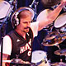
From the USA
Charlie has been with Yanni from the beginning performing on drums in rock bands when they were kids. Charlie’s energy, stage performance and stamina gets every audience on their feet all around the world.

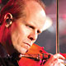
Benedikt Brydern

From Germany
Benedikt has a background in jazz violin and brings his unique style to Yanni’s music. He has been touring with the Yanni orchestra for 4 years.

Jason Carder
From the USA,
Jason has shared his talents as a professor of jazz trumpet at the University of Miami. He has toured with Yanni for 4 years and uses his flugelhorn to reach unimaginable notes.

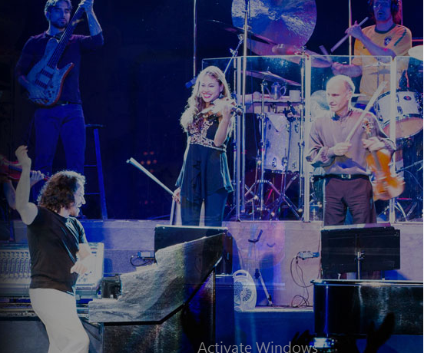
Yoel Del Sol
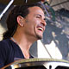
From Cuba,
Yoel has been Yanni’s leading percussionist for 4 years performing the congas like no other.
He brings an energy and Latin flair to stage.
Victor Espinola
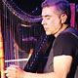
From Paraguay,
Victor is a unique performer who brings a dynamic injection of unique style to the harp. Victor has been with the Yanni orchestra for a decade.

Ming Freeman
From Taiwan,
Ming has been with Yanni for almost two decades touring as the lead keyboardist. Ming’s solos feature his true talents and showcases just how fast and rhythmic he can be on the keyboards.

Lauren Jelencovich
From the USA,
Lauren is classically trained at the Manhattan School of Music and has a voice capable of effortlessly hitting notes that no other singer would attempt.
Lauren has been with the tour for the past 2 years.

Lisa Lavie
From Canada,
Lisa’s powerful voice takes on some of Yanni’s most difficult compositions. As singer and songwriter, she brings energy and emotion to the stage.
Lisa has been with the tour for the past 2 years.

James Mattos
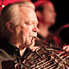
From the USA,
James has been performing on his French Horn for over 18 years with Yanni’s orchestra. He maintains the warm, rich undertones throughout the concert events

Sarah O’Brien
From England,
Sarah has toured all over the world with Yanni. Trained on cello in London’s Guildhall School of Music, she has been seen on the stage with Yanni at every major concert event.

Mary Simpson
From the USA of Chinese decent,
Mary plays her “fiddle” bringing a warmth and richness with a bluegrass edge – her style and her smile capture the hearts of every audience. Mary has been touring with Yanni for the past 2 years.

Dana Teboe
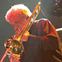
From the USA,
Dana is a widely recognized trombone player who has impeccable tone, accuracy and energy. Dana has been performing with Yanni for 8 years

Gabriel Vivas
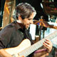
From Venezuela,
Gabriel brings a new life to the bass performing runs and scales rarely seen. Gabriel has been with Yanni since 2008 and remains a top performer.

Samvel Yervinyan
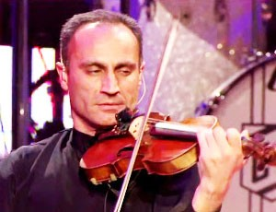
From Armenia,
Samvel has been widely recognized as one of the world’s premier violinists and has been a star performer among Yanni's orchestra for the past decade

Alexander Zhiroff
From Russia,
“Sacha” has been touring with Yanni for almost 17 years performing at all the major concert events around the world with his cello. Sacha performs with a unique style and incredible talent.

But those are not the whole orchestra, yanni gives the chance to the talented musicians to show their skills together from all over the world, make mix between different cultures to create something new and creative.
We can state some of the musicians and singers who participated in some of yanni،s parties:
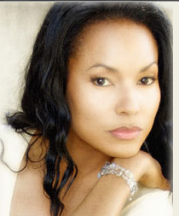

Vann Johnson: a special singer and songwriter.
Singed “love is all” with yanni and his orchestra in front of Taj Mahal, VANN continues to delight and mesmerize audiences all over the world.
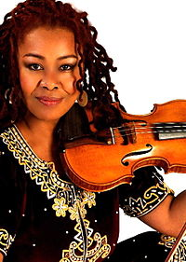

Karen Briggs
From Manhattan, NY. Grew up in Virginia. Has played violin since she was a teenager.
Karen has been a part of yanni’s orchestra in front of Taj Mahal.

Conclusion……………………………………..
Yanni as we saw is one of many successful musicians who succeed to make their own special music and transfer their feelings to the listener.
And not only that, what specialized him is that he gave places in his orchestra for many talented players from different cultures and countries to make something new, and we can see that in many parties he did like “love is all”,”………..”, maybe because he has special vision about the music ,it doesn’t relate
To Greece, United States, Armenia or any other country, it doesn’t have any borders like what he sees.

References
1-http://www.yanni.com/orchestra
2-http://www.amazon.com/Yanni-Live-The-Concert- Event/dp/B000G8NY4U
3- http://www.mtv.com/artists/yanni/biography/

